AMP - Advanced Malware Protection

Firepower Threat Defense devices allows you to perform Cisco Advanced Malware Protection (AMP) with AMP for Networks and AMP Threat Grid. With this feature, you can use Firepower Threat Defense devices to detect and block malware in files transmitted over your network. To support this feature license, you can purchase the Malware (AMP) service subscription as a stand-alone subscription or in combination with Threat (TM) or Threat and URL Filtering (TMC) subscriptions.

Real-time threat management

Control access to your network, control application use, and defend against known attacks.

Use AMP and sandboxing technologies to address unknown attacks and track malware infections through your network.
Security automation

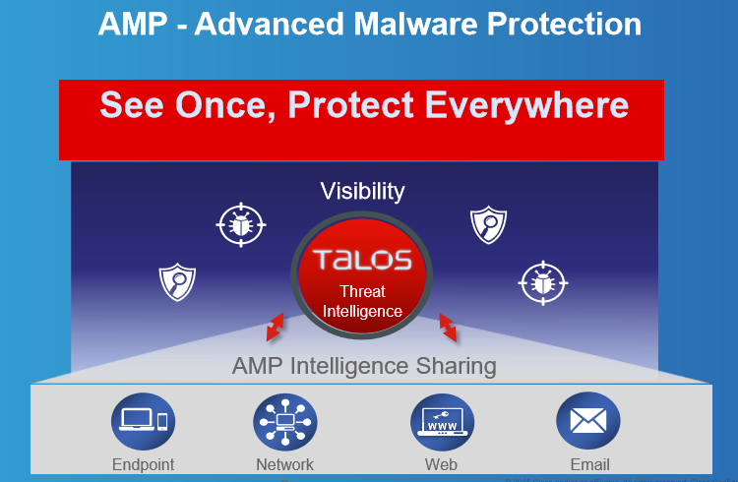

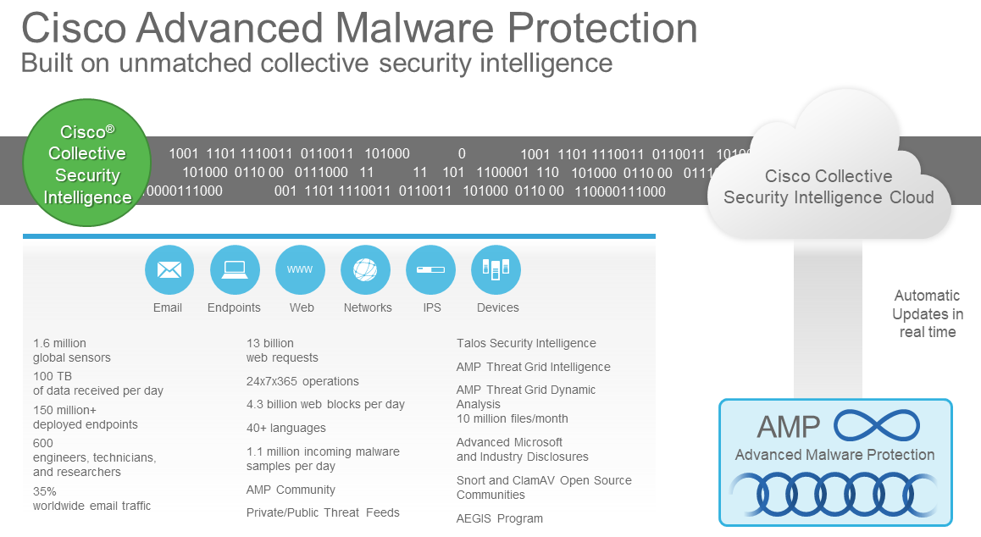

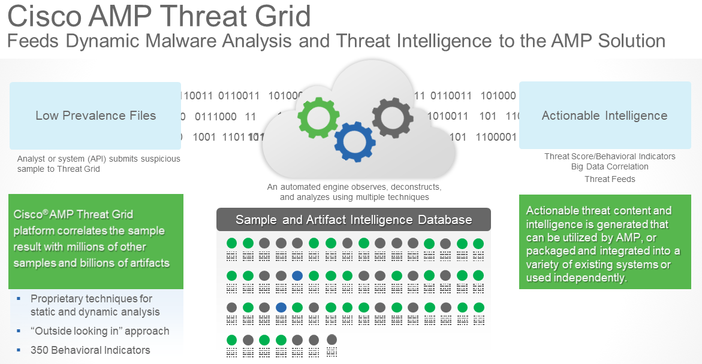

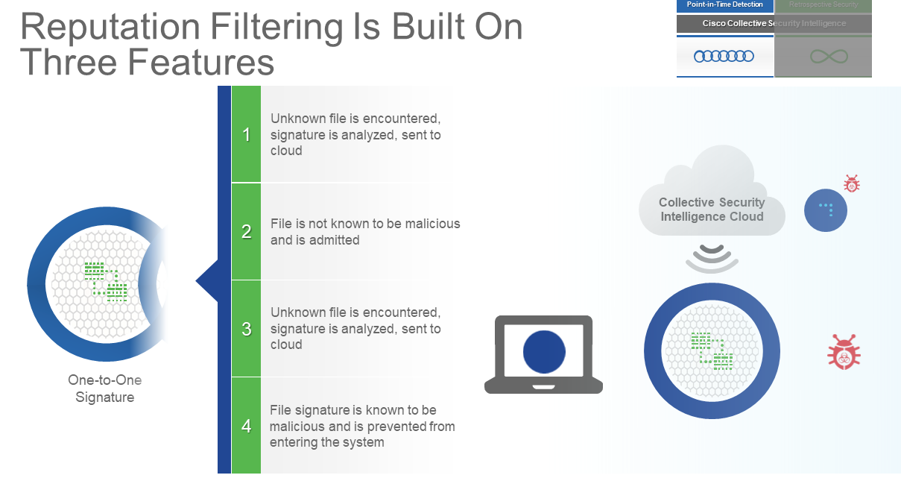

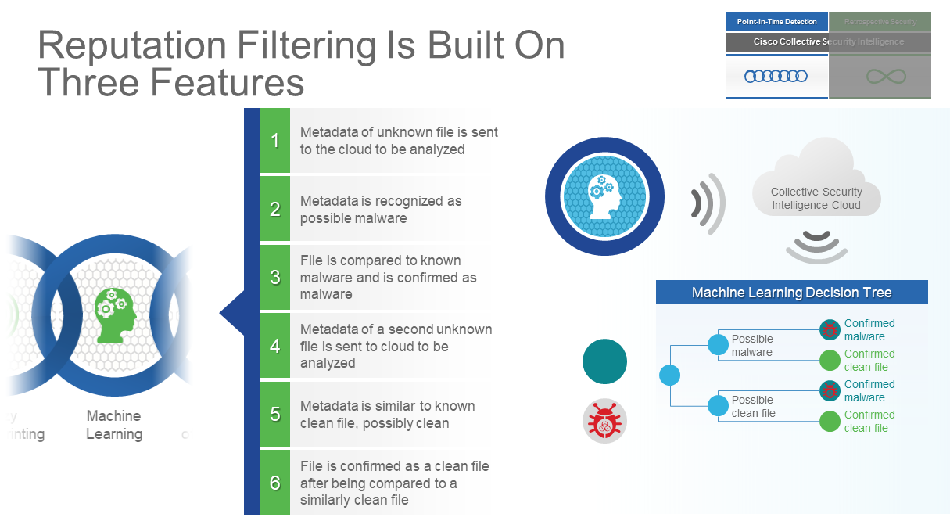

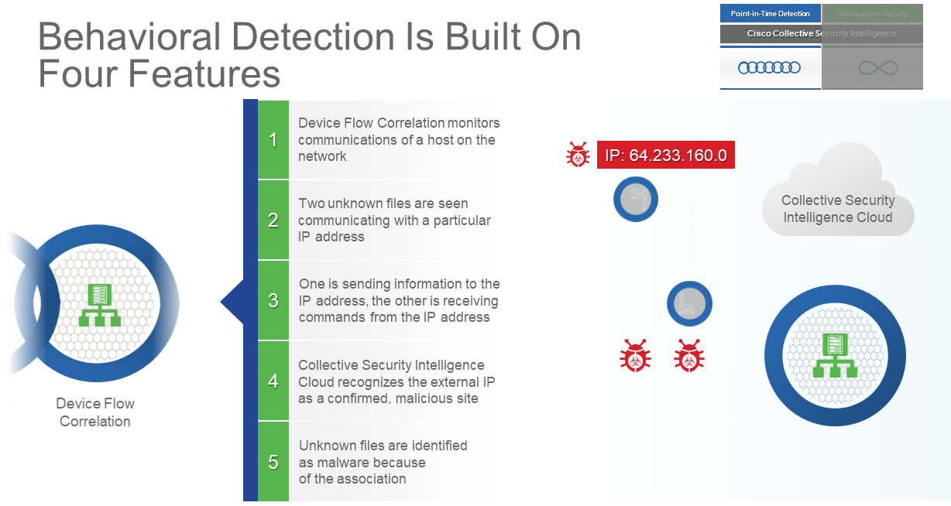

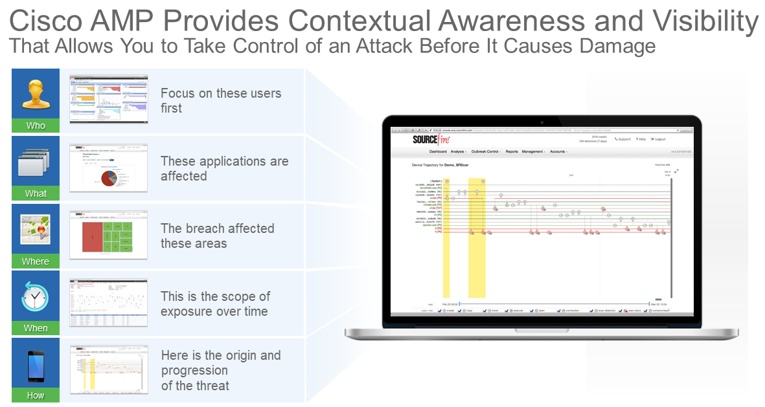

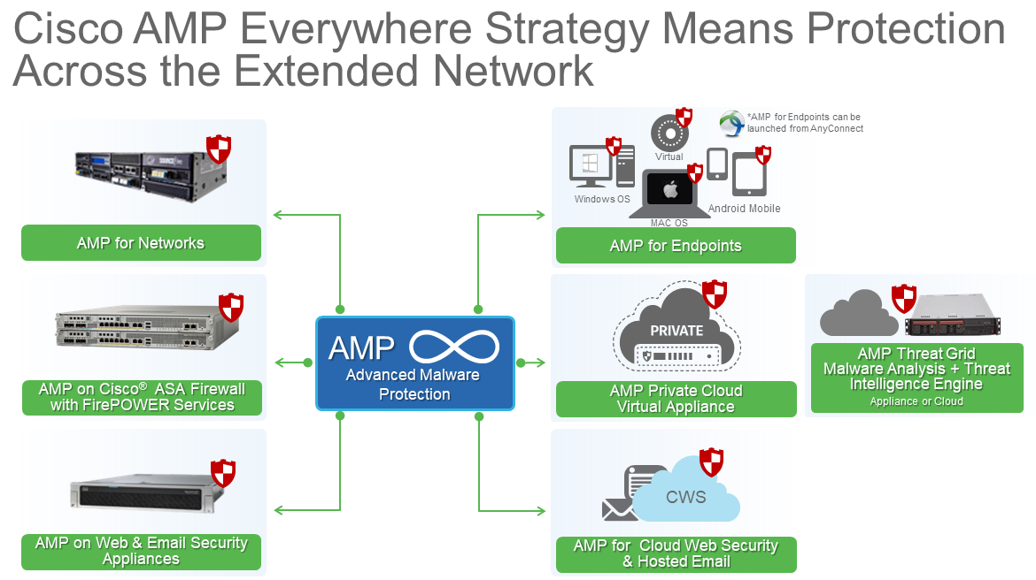

Sourcefire Resources

- Advanced Malware Protection
- Cisco AMP Threat Grid - Appliances
- Cisco AMP Threat Grid - Cloud
- Cisco Advanced Malware Protection Virtual Private Cloud Appliance
- Cisco Advanced Malware Protection for Endpoints
- Cisco Advanced Malware Protection for Networks

