Data protection and recovery for Microsoft® Office SharePoint® Server 2007
Author:
Bruno Lanceleaux and the Office SharePoint Server 2007 Product Team
Date published:
October 2007
Updated:
September 2008
Summary:
This paper describes content recovery, site recovery, and disaster recovery strategies for Office SharePoint Server 2007 deployments.
Acknowledgements
The Microsoft Office SharePoint Server Content Publishing team thanks the following technical reviewers on this paper:
- Ivan Wilson, SharePoint MVP, http://guru-web.blogspot.com/
- Ben Curry, SharePoint MVP, http://mindsharpblogs.com/Ben/
- Bob Fox, SharePoint MVP, http://bobfox.securespsite.com/FoxBlog/default.aspx
- Joel Oleson, http://www.sharepointjoel.com/default.aspx
- Gabe Bratton, SharePoint Supportability Program Manager, Microsoft
- Samer Sawaya, Program Manager, Microsoft
- Nakul Joshi, Senior Consultant, Microsoft India
- Steve Peschka, Lead Architect, Microsoft
- Troy Starr, Tester, Microsoft
- Patrick Simek, Developer, Microsoft
- Scott St. Jean, Program Manager, Microsoft SharePoint Online

The information contained in this document represents the current view of Microsoft Corporation on the issues discussed as of the date of publication. Because Microsoft must respond to changing market conditions, it should not be interpreted to be a commitment on the part of Microsoft, and Microsoft cannot guarantee the accuracy of any information presented after the date of publication.

This White Paper is for informational purposes only. MICROSOFT MAKES NO WARRANTIES, EXPRESS, IMPLIED OR STATUTORY, AS TO THE INFORMATION IN THIS DOCUMENT.

Complying with all applicable copyright laws is the responsibility of the user. Without limiting the rights under copyright, no part of this document may be reproduced, stored in or introduced into a retrieval system, or transmitted in any form or by any means (electronic, mechanical, photocopying, recording, or otherwise), or for any purpose, without the express written permission of Microsoft Corporation.

Microsoft may have patents, patent applications, trademarks, copyrights, or other intellectual property rights covering subject matter in this document. Except as expressly provided in any written license agreement from Microsoft, the furnishing of this document does not give you any license to these patents, trademarks, copyrights, or other intellectual property.

© 2008 Microsoft Corporation. All rights reserved.

Microsoft, InfoPath, SQL Server, SharePoint, Windows, and Windows Server are either registered trademarks or trademarks of Microsoft Corporation in the United States and/or other countries.

Table of Contents
Executive summary 1
Levels of data recovery in Office SharePoint Server 2007 1
Solutions for data recovery 1
Content recovery 2
Versioning 2
Recycle Bin 3
Site recovery 4
Office SharePoint Designer 2007 6
Microsoft IT Site Delete Capture feature 1.0 (Web Delete event) 6
SQL Server database snapshots 7
Disaster recovery 7
Office SharePoint Server components 7
Binary files 8
Configurations 8
Customizations 10
Content 11
Microsoft tools for backing up and recovering Office SharePoint Server 11
Office SharePoint Server built-in backup and recovery tools 13
SQL Server backup and recovery 16
Microsoft System Center Data Protection Manager 2007 17
Windows Server Backup 18
Components and backup tools 18
Planning your disaster recovery strategy 22
Determine likely recovery scenarios 22
Recommended backup standards 22
Recommended recovery environment 24
How to perform content recovery, site recovery, and disaster recovery tasks 24
Content recovery 24
Versioning 24
Recycle Bin 25
Site recovery 27
Use Office SharePoint Designer 2007 to back up a Web site 27
Use Office SharePoint Designer 2007 to restore a Web site 28
Use Microsoft IT Site Delete Capture 1.0 to capture and restore deleted Web sites 28
Create and view a database snapshot of an Office SharePoint Server content database 28
Disaster recovery 29
Backup procedures 29
Recovery procedures 33
Summary 46

Executive summary
For organizations that adopt Microsoft® Office SharePoint® Server 2007, it is important to prepare robust plans and approaches for recovering data and services as part of daily business and in the event of a catastrophe.
Our goal is to explain how administrators managing deployments can protect and recover data. This paper describes data recovery from the item level to the farm level. This paper describes only data protection and recovery, not high availability or server redundancy.
You may want to download and print the Office SharePoint Server 2007 Data Protection and Recovery model (http://go.microsoft.com/fwlink/?LinkId=124087&clcid=0x409) that accompanies this article. It provides a poster-sized summary of the content in this article.

Levels of data recovery in Office SharePoint Server 2007
There are several levels of data recovery available in Office SharePoint Server 2007: content recovery, site recovery, and disaster recovery. Each level addresses a different business issue and is often performed by persons in different roles within an organization.
- Content recovery refers to recovering a document or list by using the Recycle Bin or versioning. Content recovery is a frequent and small-scale activity, and it can be performed by end users and site administrators.
- Site recovery refers to using tools to recover from accidental deletion or data corruption of a site. Site recovery can be performed by site administrators.
- Disaster recovery refers to performing recoveries (by using built-in tools or external tools or both) and possibly migrating a site, database, or farm to new hardware. Disaster recovery can be performed by farm administrators.

Solutions for data recovery
The following table shows the various backup and restore solution options supported by Office SharePoint Server 2007 and the objects that can be protected by each solution.
Data protection tool | Types of recoverable objects
 | Farm | Search | Web application | Content database | Site collection | Site | List item/  document | Previous version | Configurations | Customizations
Microsoft System Center Data Protection Manager (DPM) | Yes | Yes | Yes | Yes¹ |  | Yes | Yes |  | Yes, requires additional configuration | Yes, requires additional configuration
SharePoint farm backup and recovery | Yes | Yes | Yes | Yes
VSS Writer | Yes | Yes | Yes | Yes |  | Yes |  |  | Possible, depends on solution | Possible, depends on solution
SQL Server |  |  |  | Yes | Yes²
Stsadm site collection backup and recovery |  |  |  |  | Yes³
SharePoint Recycle Bins |  |  |  |  |  |  | Yes
SharePoint versioning |  |  |  |  |  |  |  | Yes⁴
Stsadm import and export |  |  |  |  |  | Yes
SharePoint Designer backup |  |  |  |  |  | Yes
MSIT Site Delete Capture tool |  |  |  |  |  | Yes
 | ¹DPM can be used to restore content databases if you add the databases to a protection group, without adding the SharePoint farm to the group.
 | ²SQL Server backup and restore can be used for site collection restores if a single site collection is stored in a database.
 | ³Site collection backups are extremely processor- and memory-intensive. They are not recommended for regular use nor for site collections larger than 12 GB.
 | ⁴Previous versions are not sent to the Recycle bins when they are deleted, and are not restored when any type of backup is recovered.

Content recovery
You can enable content recovery by using the built-in Office SharePoint Server versioning and two-stage Recycle Bin features.

Versioning
Versioning addresses the issue of losing data by overwriting a document. It allows the document library to keep multiple copies of the same document. In the event of an unwanted change, an overwrite, or a document corruption, the previous version can easily be restored by the end user. You turn on versioning at the library or list level. Items and files can be versioned.
The following settings can be found through the Document Library page. Click the Settings menu, choose Document Library Settings, and then click Versioning Settings in the General Settings section.
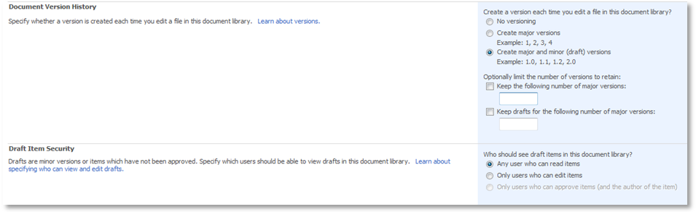
Microsoft Office SharePoint Server 2007 contains three options for versioning:
- No versioning: Previous document versions and the history (such as comments) associated with each version are not retrievable. This is the default setting.
- Create major versions: Also known as Simple Versioning. Each iteration becomes a full copy of the document with the versions numbered sequentially (1, 2, 3, and so on). All users with permissions to the document library are able to view every updated version. Use this option if you do not need to differentiate between Draft versions and Final/Published versions. To control the effect on storage space, you can specify how many previous versions to keep based on the current version.
- Create major and minor versions: Versions ending with a zero extension (.0) are major version and versions ending with a non-zero extension are minor versions. Only major versions can be published. Additional permission levels can be configured for working with minor versions. In most scenarios, end-users who can edit major versions are also allowed to edit minor versions, but read-only users can only view major versions. As with the previous option, you can specify how many previous versions to keep based on the current version. You can also specify how many minor versions should be kept per major version.
Note: Versioning for standard lists is limited to major versions only.
When properly understood and implemented, versioning not only provides a user-driven content recovery method but can also inform an end-user about the stage of development of a document. For example, Is this document a Draft or a Published version? Which changes have been made recently? Has the metadata changed, and why?

Recycle Bin
Unlike with previous versions of Office SharePoint Server, you do not need to perform a content database recovery to retrieve deleted objects in Microsoft Office SharePoint Server 2007. The product provides a two-stage Recycle Bin.
The first-stage Recycle Bin (or user-stage Recycle Bin) is located at the end-user level. It provides an “un-delete” feature that allows end users with appropriate permissions to recover accidentally deleted files, documents, list items, lists, and document libraries from a site.
The second-stage Recycle Bin (or site-collection Recycle Bin) is located at the site collection administrator level. The second-stage Recycle Bin is organized into two views: objects in the first-stage Recycle Bins of all sites in the site collection, and objects in the second-stage Recycle Bin. When an item is deleted from the first-stage Recycle Bin, it can only be recovered by a site collection administrator from the second-stage Recycle Bin.
Recycle Bin settings are set at the Web application level, in the SharePoint Central Administration Web site. Click Application Management, and then click Web application general settings under the SharePoint Web Application Management section.
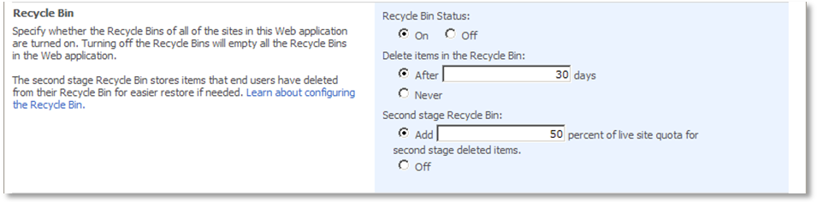
Features of the Recycle Bins
- The Recycle Bins collect deleted documents and list items (documents, document versions, document libraries, picture libraries, announcements, calendars, links, tasks, folders, pages, team discussions).
- When a list item is deleted, any attachments to the item are also deleted and can be restored from the Recycle Bin.
- Items cannot be opened or viewed while in the Recycle Bin. An item must first be restored before it can be opened or viewed.
- By default, items in both Recycle Bins are automatically deleted after a specified time period (the default setting is 30 days). If the second-stage Recycle Bin reaches its size limit, the oldest items are also automatically deleted.
Note: Items move from the first-stage Recycle Bin to the second-stage Recycle Bin only when the first-stage Recycle Bin is emptied. The time limit for the Recycle Bins applies to the total time after initial deletion—not the time spent in either Recycle Bin stage.
- Turning off the Recycle Bin for a Web application empties all Recycle Bins and permanently deletes all items in them.
- The Recycle Bins can contain multiple copies of a document with the same file name and source. These documents cannot be recovered over an existing copy of a document.
- The Recycle Bins cannot be used to recover previous versions or accidental overwrites of documents—you must use versioning.
- Site and site collection deletion is not managed through the Recycle Bins.

Facts about the first-stage Recycle Bin:
- Items located in the first-stage Recycle Bin count toward the site quota.
- End users must have Contribute, Design, or Full Control permissions on a site to perform delete and recovery operations.
- By default, items are sorted in descending order by date deleted.

Facts about the second-stage Recycle Bin:
- You can specify the amount of space to reserve for second-stage deleted items as a percentage to add to the live site quota.
- Items stored in the second-stage Recycle Bin do not count toward the site quota. However, the size that is specified for the second-stage Recycle Bin increases the total size of the site and the content database that hosts it. If no site quota has been set, there is no limit on the size of the second-stage Recycle Bin.
- You can turn off the second-stage Recycle Bin.
- Only site collection administrators can restore from this stage.
- By default, items are sorted in descending order by date deleted. The following columns are provided to sort in ascending or descending order: Name, Original Location, Created By, Deleted (Date and Time), and Size.

Site recovery
Directly recovering a deleted site is not a feature that is available in Office SharePoint Server 2007. Site deletion is most common in development environments. If you must frequently recover a single site in a production environment, you might want to create a site collection that contains only that site. You can then use SQL Server tools to back up that particular site collection. For more information about using SQL Server tools, see SQL Server backup and recovery.
Microsoft provides the following tools that you can use to back up, version, and recover a site:
- Microsoft Office SharePoint Designer 2007
- Stsadm export and import operations
- Microsoft IT Site Delete Capture feature 1.0
- Server database snapshots

Office SharePoint Designer 2007
Office SharePoint Designer 2007 provides the ability to back up and restore sites and site collections, down to the individual file level, and to remove them from the network for offline use. This functionality is based on the Stsadm export and import operations and is similar that of smigrate.exe in SharePoint Portal Server 2003. Backup is limited to sites less than 25 MB in size.
Use the Backup and Recovery feature in Office SharePoint Designer when you want to make a backup copy of the content of a site or subsite, or when you want to move a site or subsite to another server or location. To use the Backup and Recovery feature, you must have administrator permissions to the site being backed up, but a direct connection to the server is not necessary.
Backing up a Web site creates a content migration package, or .cmp file. When you back up a Web site, you can choose to back up either the top-level Web site or the top-level Web site and any subsites. The backup file that you create includes: list or library content, security settings, user information, navigation, customizations, and personalizations (such as views, site templates, and content types). The backup file does not include workflow definitions, running workflows, alerts, or properties stored at the site-collection level.
Note: The backup file does not include the Recycle Bin state or objects inside it.
You must be a site or farm administrator to perform backups by using Office SharePoint Designer.
For more information, see Back up, restore, or move a SharePoint site (http://go.microsoft.com/fwlink/?LinkID=87003&clcid=0x409).

Stsadm export and import operations
You can use the Stsadm export and import operations to archive and re-insert a site or subsite. Although using the export operation saves data for you, it does not produce a full-fidelity backup. The export operation can include content and security settings only. It does not include customizations and settings such as workflow, alerts, features, solutions, or Recycle Bin state.
The account that you use to run the Stsadm command-line tool must be a member of the Administrators group on the local computer. The account must also be a member of the db_owner fixed database role in SQL Server.

Microsoft IT Site Delete Capture feature 1.0 (Web Delete event)
When a site is deleted, Office SharePoint Server generates a Web Delete event. Microsoft IT (MSIT) has created Microsoft IT Site Delete Capture feature 1.0 to detect and act on the Web Delete event. When a Web Delete event is detected, the feature archives the site to a file share before it is removed from the configuration and content databases. You can also configure the feature to send e-mail messages when a site has been archived and deleted, or if a site could not be archived and deleted. The Microsoft IT Site Delete Capture feature 1.0 is available from CodePlex governance (http://go.microsoft.com/fwlink/?LinkID=92682&clcid=0x409).
Note: This tool is not part of Office SharePoint Server, and may not be updated. This tool is built on supported Microsoft technologies, but it is not supported by Microsoft. You must be a site or farm administrator to install and configure Microsoft IT Site Delete Capture feature 1.0.

SQL Server database snapshots
A SQL Server snapshot is a read-only view of a database as the database existed at the time that the snapshot was created. SQL Server snapshots are created by using differential copying. After the snapshot is created, the snapshot technology uses a copy-on-write scheme to make sure that the snapshot images are static views of the database.
Database snapshots are not a backup method. You can use snapshot technology to create a read-only, point-in-time copy of a running content database in Office SharePoint Server. You can associate a snapshot content database with a SharePoint site to let users retrieve content from a different point in time.
Note: The snapshot version of the Web site does not have full functionality. For example, you cannot write to the snapshot version or upload a file to it. Database snapshots are available in SQL Server 2005 or later.
For more information about using snapshots with Office SharePoint Server, see this article in the Microsoft Knowledge Base: How to use SQL Server to take a snapshot of a Windows SharePoint Services 3.0 content database (http://go.microsoft.com/fwlink/?LinkID=99636&clcid=0x409).

Disaster recovery
When you recover from a disaster, you want to try to save as much data and as many settings as you can and restore them as quickly as possible. The backup and recovery tools described in this section can help you protect and recover your system.
Note: Backing up and restoring data and components in Office SharePoint Server is often performed for purposes other than disaster recovery. For instance, you can back up and restore data as part of a migration to a different environment, or as part of scaling out your system.

Office SharePoint Server components
An Office SharePoint Server system includes the following components:
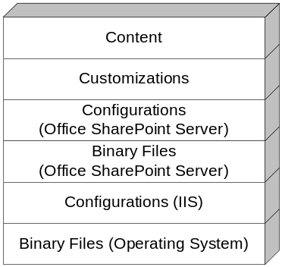
Your backup and recovery strategy should address each of these components on the servers in your system.
The strategy you adopt for backup and recovery is often affected by whether your environment is customized and, if customized, whether change management and customizations are managed centrally or are decentralized. We consider an environment to be centralized if all customizations and changes are rolled out and managed centrally, and decentralized if some customizations are not managed centrally.
The following sections describe backup and recovery strategies for each component.

Binary files
For both operating system files and Office SharePoint Server program files, we recommend that you use a file-system backup on a regular basis, such as Windows Server® 2003 Backup (NTBackup) or Windows Server 2008 Backup. Additionally, we recommend that you keep copies of the installation disks for your operating system, SQL Server, Office SharePoint Server, and software updates both on- and off-site.
In the event that you need to restore a system, we recommend that you reinstall the operating system, SQL Server, and Office SharePoint Server. We recommend that you keep backups so that you can roll back software updates and validate that you have correctly reconfigured your system.

Configurations
Office SharePoint Server includes Internet Information Services (IIS) configurations and configurations stored in the configuration database and Central Administration content database.

IIS Configurations
Internet Information Services (IIS) configurations are set in Central Administration or IIS Manager on each front-end Web server in your system, and they are also set on any computers in your system that run SQL Server Reporting Services.
IIS configurations are stored in the IIS metabase. The metabase is a plain-text XML file on each front-end Web server that can be modified by using IIS Manager, or directly by Office SharePoint Server. The metabase is susceptible to being corrupted or overwritten, and it should be included in your backup strategy. IIS configurations include the following:
- Application pool settings, including service accounts
- HTTP compression settings
- Time-out settings
- Custom Internet Server Application Programming Interface (ISAPI) filters
- Computer domain membership
- Internet Protocol security (IPsec) settings
- Network Load Balancing settings
- Host header entries
- Secure Sockets Layer (SSL) certificates
- Dedicated IP address settings
In previous versions of SharePoint Products and Technologies, we recommended that you back up the IIS metabase. Conversely, for this version of SharePoint Products and Technologies, we recommend that you document all IIS configurations for each front-end Web server, if possible, by using a tool that provides Desired Configuration Monitoring (DCM).

Configurations stored in the configuration database and Central Administration content database
Configurations in Office SharePoint Server are set in Central Administration and stored in the configuration database and the Central Administration content database.
Important: Although the configuration database and Central Administration content database can be backed up, restoring backups of the configuration database and Central Administration content database taken from a running farm by using the tools built in to SharePoint Products and Technologies or SQL Server is not supported.
This is because data in these databases may not be synchronized with data in other Office SharePoint Server 2007 or Windows SharePoint Services 3.0 databases. Therefore, the tools built in to SharePoint Products and Technologies do not recover these databases during a farm-level restore operation.
If this data is not synchronized, users might experience various random errors. For more information, see Microsoft Knowledge Base article 948725: Restoration of the configuration database is not supported in SharePoint Server 2007 and in Windows SharePoint Services 3.0 (http://go.microsoft.com/fwlink/?LinkId=117755&clcid=0x409).
You can recover a farm, including the configuration database and Central Administration content database, in the following ways:
- You can use farm-level backups of a running farm taken with System Center Data Protection Manager to recover an entire farm, including the configuration database and Central Administration content database. For more information, see How to Recover a Windows SharePoint Services Farm (http://go.microsoft.com/fwlink/?LinkId=102831&clcid=0x409).
- You can restore a backup of the configuration database and Central Administration content database taken from a fully stopped farm. For more information, see Move all databases to a new server (http://go.microsoft.com/fwlink/?LinkId=118325&clcid=0x409).
If the configuration or Central Administration content databases of a farm become unsynchronized, you must re-create both databases by using the SharePoint Products and Technologies Configuration Wizard or Psconfig command-line tool.
To protect the configuration database and Central Administration content database:
- Document all configuration settings and all your customizations so that you can correctly re-create the databases. For more information about recovering a farm, see Recover from an unsynchronized configuration database (http://go.microsoft.com/fwlink/?LinkId=118324&clcid=0x409).
- Consider a redundancy solution, such as clustering or mirroring, for the computer running SQL Server that is hosting the configuration database. For more information about using mirroring, see Using Database Mirroring with Office SharePoint Server and Windows SharePoint Services (http://go.microsoft.com/fwlink/?LinkId=83725&clcid=0x409).
Configuration settings in Office SharePoint Server include the following:
- Application pool settings, including service accounts (all accounts that run as Web applications, including the crawler account and the search account).
- Alternate access mapping settings.
- Farm-level search settings.
- External service connection settings.
- Workflow management settings.
- E-mail settings.
- A/V settings.
- Usage analysis processing settings.
- Diagnostic logging settings.
- Content deployment settings.
- Timer job settings.
- HTML viewer settings.
- Recycle Bin settings and other Web application general settings.
- Administrator-deployed form templates.
- Default quota templates.
- Database names and locations.
- Web application names and databases. Be sure to document the content database names associated with each Web application.
- Crawler impact rules.
- Activated features.
- Blocked file types.
You can easily document alternate access mapping (AAM) settings. You can export your AAM settings to a text file by using the command stsadm -o enumalternatedomains and then back up the text file by using a file system backup solution.
A method of automating the recovery of a farm, including configurations, is to script your installation and update the installation script whenever you change a configuration. You can then run your installation script when you need to recover a farm. This is a relatively complex procedure, and should be thoroughly tested. For more information about scripted installations, see the following resources:
- Installing Office SharePoint Server 2007 by using the command line (http://go.microsoft.com/fwlink/?LinkId=118674&clcid=0x409).
- Joel Oleson’s blog entry: Scripted, Unattended and Silent Installs (http://blogs.msdn.com/joelo/archive/2007/07/16/unattended-and-silent-installs.aspx).
- Ben Curry’s blog entry: Scripted SharePoint Farm Installation using PSConfig.exe and stsadm.exe (http://mindsharpblogs.com/ben/archive/2008/03/08/4411.aspx).

Customizations
Customizations to SharePoint sites can include:
- Master pages, page layouts and cascading style sheets. These objects are stored in the content database for a Web application.
- Web Parts, site or list definitions, custom columns, new content types, custom fields, custom actions, coded workflows, or workflow activities and conditions.
- Third party solutions and their associated binary files and registry keys, such as IFilters.
- Changes to standard XML files.
- Custom site definitions (webtemp.xml).
We recommend that all customizations be packaged as solutions. A solution is a container for one or more customizations. Solutions can contain features, Web Parts, security policy changes, and other files with a detailed guide to allow the automated deployment to the file system by the deployment mechanisms in SharePoint Products and Technologies. Solutions include IFilters. Features are portions of solutions that can be activated by the server administrator against the farm, a specific Web application, a specific site collection, or a specific Web site. For more information about deploying customizations by using solution packages, see Deploy customizations (http://go.microsoft.com/fwlink/?LinkID=118314&clcid=0x409).
On front-end Web servers, customization files are stored in Program Files\Common Files\Microsoft Shared\Web server extensions\12, often referred to as the “12 hive.” Some customizations also write changes to the Web.config file.
For centrally-managed systems, we recommend that you use solution packages to deploy all SharePoint site customizations. You can use solution packages to simplify the backup and recovery process. Back up each solution package, both onsite and offsite, and then, in the event of a disaster, redeploy the solution to the appropriate servers.
For decentralized systems, or systems in which customizations have not or cannot be packaged as solutions, backing up and restoring customizations is a more complex process. The following table lists the locations where customizations are often stored on front-end Web servers. Consult with your development team or customization vendor to determine whether your customizations involve additional add-in software or files in other locations. We recommend that you back up these directories with a file system backup solution.

Location | Description
Program Files\Common Files\Microsoft Shared\Web server extensions\12 | Commonly updated files, custom assemblies, custom templates, custom site definitions.
Inetpub | Location of IIS virtual directories.
C:\WINNT\assembly | Global assembly cache (GAC). A protected operating system location where .NET Framework code assemblies are installed to provide full system access.

Content
Office SharePoint Server content is stored in SQL Server databases. The following diagram shows the databases associated with an Office SharePoint Server implementation. As noted in the diagram and previously, we do not recommend that you rely on backups of the configuration and Central Administration content database for the purposes of disaster recovery, as they can only be restored to an environment with precisely the same configurations.
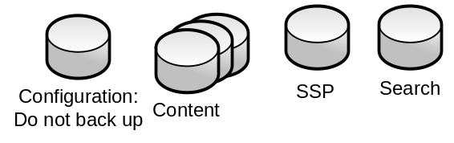
We recommend that you back up all content and Shared Services Provider (SSP) databases using either Office SharePoint Server built-in tools, other Microsoft tools, such as SQL Server or Microsoft System Center Data Protection Manager, or third-party tools built on supported APIs and SharePoint Products and Technologies. The Search database is a special case—you should only back it up using Office SharePoint Server tools, or System Center Data Protection Manager. These tools synchronize the Search database backup with the Search index file backup, and both can be restored together.
Note: We do not recommend that you back up the Search database with SQL Server tools, because the database cannot be synchronized with the index file. After you restore a Search database backed up with SQL Server tools, Office SharePoint Server performs a full crawl of the content to re-create the index.

Microsoft tools for backing up and recovering Office SharePoint Server
The following table lists Microsoft tools that you can use for disaster recovery. Each tool is then described in detail. Third-party tools are not described in this document.

Office SharePoint Server built-in backup and recovery tools
Office SharePoint Server provides two built-in backup and recovery tools: Central Administration and the Stsadm command-line tool.
The following diagram shows how built-in Office SharePoint Server backup or recovery works. A backup is triggered from either Central Administration or the Stsadm command-line tool. The Central Administration application pool writes files to the specified file server and triggers a SQL Server database backup to the same file server. The path provided to the backup is the location where a folder is created for backup (spbr0000, spbr0001, and so on).
The processes that are running and the accounts they are running as (the Central Administration application pool and the account that the SQL Server services are running as), must have write permissions to the directory that you are backing up to. To perform a backup, you must be an administrator on the farm. To run a recovery operation, you need to be a farm administrator and a local administrator on the front-end Web servers.
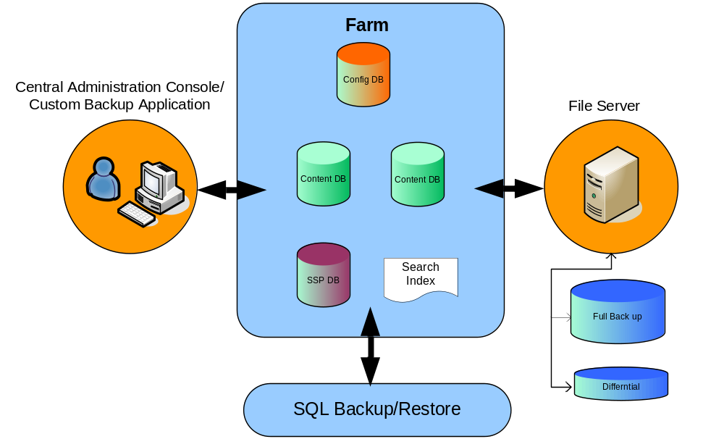

Central Administration
Central Administration provides an easy way to back up your Office SharePoint Server system.
You can back up and restore at various levels, the highest being the entire farm and the lowest being a content database. Full and differential backups are also available. The backup and recovery jobs for Central Administration are run by the SPTimer service.
Benefits of this tool:
- Provides the ability to back up and restore at the farm level or Web application level.
- Provides restorable backups for Search.
- Easy-to-use recovery tool.
- For backups that initially run 17 hours, the system automatically restarts the backup after calculating and allotting the additional time (over 17 hours) required for the process to complete.
Disadvantages of this tool:
- Does not provide scheduling functionality.
- Does not provide automatic deletion of old backup files. You may want to use the backup file deletion script provided in the following Microsoft Knowledge Base article: How to automate the deletion of backups in SharePoint Server 2007 and in Windows SharePoint Services 3.0 by using a Visual Basic script (http://go.microsoft.com/fwlink/?LinkId=102617&clcid=0x409).
- Cannot back up directly to tape. Backup location must be a UNC path.
- As part of a farm backup, can back up the configuration database and the Central Administration content database, but will not restore them. For more information, see the Configurations section.
- Does not back up any configuration changes or custom solution files in the Inetpub or Office 12 hive (Program Files\Common Files\Microsoft Shared\Web server extensions\12).
- Does not back up any customizations made to the Web.config file
- Does not back up alternate access mappings (AAM).
- Does not back up Internet Information Services (IIS) settings including host headers, dedicated IP addresses, and Secure Sockets Layer (SSL) certificates.
- If a backup or recovery job is not successful, the unsuccessful job must be manually deleted from the Timer job list on the Backup and Restore Status page. In Central Administration, click Operations, and then click Backup and Restore Job Status. If the failed job is not deleted manually, subsequent backup or recovery jobs fail.
For more information, see Back up Office SharePoint Server 2007 by using Central Administration (http://go.microsoft.com/fwlink/?LinkId=102618&clcid=0x409).

Stsadm command-line tool
Microsoft Office SharePoint Server 2007 includes the Stsadm.exe tool for command-line administration of servers and sites. This document describes only the Stsadm backup and restore operations. Many other operations are available.
The account that you use to run the Stsadm command-line tool must be a member of the Administrators group on the local computer.
Note: The Stsadm command-line tool can be used to back up the configuration database and Central Administration. However, the configuration database and Central Administration can only be restored to a server of the same name, in precisely the same location. We assume that in most cases you will be restoring either to a different farm or to a different server; therefore we do not describe how to back up and restore the configuration database.
Benefits of this tool:
- Can be used with Windows Task Scheduler to schedule backups.
- Backups can be delayed or repeated by using a batch file and the Windows Task Scheduler.
- Provides restorable backups for Search.
- Provides the ability to back up and restore at the farm level, Web application level, or site-collection level. Stsadm full backups can be used to restore an entire farm or to restore parts of a farm: Web application, Shared Services Provider, or content database. When recovering a site collection or database to restore specific content items, we recommend that you use a recovery farm. For more information, see Recommended recovery environment.
- For backups that initially run 17 hours, the system automatically restarts the backup and allots an appropriate amount of time for the process to perform (longer than 17 hours).
Disadvantages of this tool:
- Cannot back up directly to tape. Backup location must be a UNC path.
- Does not provide automatic deletion of old backup files. You may want to use the backup file deletion script provided in the Microsoft Knowledge Base article, How to automate the deletion of backups in SharePoint Server 2007 and in Windows SharePoint Services 3.0 by using a Visual Basic script (http://go.microsoft.com/fwlink/?LinkID=102617&clcid=0x409).
- As part of a farm backup, can back up the configuration database and the Central Administration content database, but will not restore them. For more information, see the Configurations section.
- Does not back up any custom solution files in the Inetpub or Office 12 hive (Program Files\Common Files\Microsoft Shared\Web server extensions\12).
- Does not back up alternate access mappings (AAM).
- Does not back up Internet Information Services (IIS) settings including host headers, dedicated IP addresses, and Secure Sockets Layer (SSL) certificates.
- Site collection backups affect performance, and can cause access errors. They are not designed to be used when the server is under active load. Site collection backups can be slow when working with collections larger than 12-15 GB. We recommend that you use farm backups if you are working with collections larger than 15 GB.
In addition to your hardware configuration, the size of the database, site collection, or Web application that you are working with can significantly affect Office SharePoint Server backup and restore performance.
If your system exceeds the following limits, or, if backing up your system exceeds the maintenance window that you have available, we recommend that you use differential backup tools outside of SharePoint for your backup and restore needs, such as Microsoft System Center Data Protection Manager.
- Content databases larger than 100 GB.
- Site collections that you want to back up individually, that are larger than 12 GB.
Note: If you want to back up a site collection individually that is larger than 12 GB, we recommend that you move it to its own database.
One way to manage the size of your search backup is to ensure that the database index is defragmented. You may want to use the defragmentation script provided in the Microsoft Knowledge Base article entitled How to defragment Windows SharePoint Services 3.0 databases and SharePoint Server 2007 databases (http://go.microsoft.com/fwlink/?LinkId=102795&clcid=0x409).

SQL Server backup and recovery
The SQL Server databases that Office SharePoint Server uses contain site content—be sure that they are backed up, either by using Office SharePoint Server backup and recovery, or by using SQL Server. If your company has database administrators that back up other SQL Server databases, you may want to include the databases used by Office SharePoint Server in your standard processes.
Benefits of this tool:
- Existing SQL Server disaster recovery strategies can be re-used.
- Full and differential backups can be configured with added verification.
- Provides a full-fidelity data backup.
- Can be faster than Office SharePoint Server backups.
- When recovering a database to restore specific content items, we recommend that you use a recovery farm. For more information, see Recommended recovery environment.
Disadvantages of this tool:
- Does not include front-end Web server custom solutions.
- Can back up the configuration database and Central Administration content database, but restoring is not supported. For more information, see the Configurations section.
- Does not back up Internet Information Services (IIS) settings set outside of Office SharePoint Server, including host headers, dedicated IP addresses and Secure Sockets Layer (SSL) certificates.
- If using Search, you must re-crawl after restoring content because indexes are not backed up in SQL Server.
- Should not be used to back up the Search database, because it cannot be synchronized with the Search index.
- You must manually reattach your databases to the Web applications after a recovery.

Microsoft System Center Data Protection Manager 2007
System Center Data Protection Manager 2007 (DPM) enables disk-based and tape-based data protection and recovery for servers in and across Active Directory domains. DPM performs replication, synchronization, and recovery point creation to provide reliable protection and rapid recovery of data both by system administrators and by end-users.
DPM can be used to protect Windows SharePoint Services 3.0 and Microsoft Office SharePoint Server 2007 in addition to Microsoft SQL Server 2000 SP4, SQL Server 2005 SP1, or SQL Server 2005 SP2; Exchange Server 2003 SP2 and Exchange Server 2007; Microsoft Virtual Server 2005 R2 SP1 and its virtual machines; Windows Server 2008 operating system; files on workstations and laptops running Windows XP Professional SP2 and all Windows Vista Editions except the Home Edition; files and application data on clustered servers; and the server system state.
For more information about installing, deploying, and configuring DPM, see the DPM 2007 documentation on TechNet: System Center Data Protection Manager 2007 (http://go.microsoft.com/fwlink/?LinkId=102807&clcid=0x409).
DPM can be used to recover content items, sites, and farms. For more information, see the following resources:
- How to Recover a Windows SharePoint Services Item (http://go.microsoft.com/fwlink/?LinkId=102815&clcid=0x409)
- How to Recover a Windows SharePoint Services Site (http://go.microsoft.com/fwlink/?LinkId=102826&clcid=0x409)
- How to Recover a Windows SharePoint Services Farm (http://go.microsoft.com/fwlink/?LinkId=102831&clcid=0x409)
Benefits of this tool:
- Provides the ability to back up and restore at the farm, database, site, or content item level. When recovering a site or content item, DPM requires the use of a single server recovery farm. For more information, see Recommended recovery environment.
- Can back up the configuration database and Central Administration content database, but restoring is only supported as part of a farm-level recovery. For more information, see the Configurations section.
- Can be used to schedule backups.
- Can back up Search.
- Can back up directly to tape, or from file to tape.
- Provides the ability to back up and restore directories that contain customizations.
- Can be used to back up and recover the server system state, including IIS configuration settings.
- Requires less processing on the server because writes are done at the data block level.
Disadvantages of this tool:
- If DPM has not already been purchased for your environment, you may require additional funding and equipment.
- Protecting search requires some additional scripting. For more information, see White paper: Microsoft Office SharePoint Server 2007 Search Backup for DPM 2007 (http://go.microsoft.com/fwlink/?LinkId=116263&clcid=0x409).

Windows Server Backup
You can use the Windows Server Backup tool to back up your home directories, Web.config file, custom assemblies, customizations, site definitions, and list definitions.
Note: As of Office SharePoint Server 2007 SP1, you can now install on Windows Server 2008.
Benefits of this tool:
- Can specify specific files and folders containing customizations.
- Can schedule backups.
Disadvantages of this tool:
- You must configure specific registry keys for Windows Server 2008 Backup to work. For more information, see Windows SharePoint Services 3.0 does not appear in the list of the components that can be backed up when you use Windows Server Backup in Windows Server 2008 (http://go.microsoft.com/fwlink/?LinkId=108244&clcid=0x409) in the Microsoft Knowledge Base.
In particular, for a customized system that is not deployed using solutions, be sure to back up the following directories.

Directory | Description
%COMMONPROGRAMFILES%\Microsoft Shared\Web server extensions\12 | The installation directory for Office SharePoint Server. Often called the "12 hive." Stores many configuration changes specific to Office SharePoint Server.
Inetpub | Location of IIS virtual directories.
C:\WINNT\assembly | Global assembly cache.
For more information, see How to use the backup feature to back up and restore data in Windows Server 2003 (http://go.microsoft.com/fwlink/?LinkId=102625&clcid=0x409).

Components and backup tools
The following table lists components of SharePoint, their default locations, and the tools we recommend for backing up each component.
Description | File system backup possible | SQL Server  Database backup possible | Default location | Backup strategy recommendations
Microsoft .NET Framework 3.0. |  |  | N/A | Do not back up. Keep the installation package for reinstalling.
IIS metabase |  |  | N/A | Document settings and reconfigure during recovery, or use the following tools.  - System Center Data Protection Manager  - Windows system backup
Binaries for Office SharePoint Server |  |  | Folder: %SYSTEMDRIVE%\Program Files\Microsoft Office Servers\12.0\Bin | Keep your initial media at on-site and off-site locations, in addition to copies of any software updates.
SharePoint Central Administration Web site and content database |  |  | Folder: C:\Inetpub\wwwroot\wss\Virtual Directories\...  Database: SharePoint_AdminContent_GUID | Do not back up. Restoring backups of the configuration database and Central Administration content database taken from a running farm is not supported because data in these databases may not be synchronized with data in other SharePoint Server 2007 or Windows SharePoint Services 3.0 databases. For more information, see the Configurations section.
Configuration database |  |  | Database: SharePoint_Config | Do not back up. Restoring backups of the configuration database and Central Administration content database taken from a running farm is not supported because data in these databases may not be synchronized with data in other SharePoint Server 2007 or Windows SharePoint Services 3.0 databases. For more information, see the Configurations section.
Office Server Web Services |  |  | Folder: %SYSTEMDRIVE%\Program Files\Microsoft Office Servers\12.0\WebServices\Root | - SharePoint Products and Technologies  - System Center Data Protection Manager
Office SharePoint Server Search Service |  |  | Folder: %SYSTEMDRIVE%\Program Files\Data\... | - SharePoint Products and Technologies  - System Center Data Protection Manager
Windows SharePoint Services Help Search Service |  |  | Database: WSS_Search_Servername  Folder: %SYSTEMDRIVE%\Program Files\Microsoft Office Servers\12.0\Data\... | - SharePoint Products and Technologies  - System Center Data Protection Manager
Web Application for Shared Services Provider (SSP) |  |  | Folder: C:\Inetpub\wwwroot\wss\Virtual Directories\...  Default Database:  WSS_Content | - SharePoint Products and Technologies  - System Center Data Protection Manager  - SQL Server
Shared Services Provider (SSP) |  |  | Folder: C:\Inetpub\wwwroot\wss\Virtual Directories\...  Default Database: SharedServicesName_Database | - SharePoint Products and Technologies  - SQL Server  - System Center Data Protection Manager
Search:  Index file (contains full-text index results)  Database (contains search metadata) |  |  | Folder: C:\Inetpub\wwwroot\wss\Virtual Directories\...  Default Database: SharedServicesName_Search_Database | - SharePoint Products and Technologies  - System Center Data Protection Manager  - SQL Server possible but not recommended—requires full crawl after restoring to rebuild index file.
Site collection Web applications |  |  | Folder: C:\Inetpub\wwwroot\wss\Virtual Directories\... | - SharePoint Products and Technologies  - System Center Data Protection Manager
Content and metadata associated with site collections |  |  | Database: WSS_Content (by default and excluding additional Content databases manually created) | - SharePoint Products and Technologies  - SQL Server  - System Center Data Protection Manager
Single-Sign-On database (Master Key) |  |  | Folder: %SYSTEMDRIVE%\%COMMONPROGRAMFILES% \Microsoft Shared\Microsoft Office 12 Single Sign-on  Database: SharedServicesName_Database | - Secure file copy to removable media  - SQL Server  - System Center Data Protection Manager
Records Management |  |  | Folder: C:\Inetpub\wwwroot\wss\Virtual Directories\...  Database: Content_Database | - SharePoint Products and Technologies  - SQL Server  - System Center Data Protection Manager
Excel Calculation Services (ECS) |  |  | Stored in SSP Database | - SharePoint Products and Technologies  - SQL Server  - System Center Data Protection Manager
InfoPath® Forms Services |  |  | Database: Config_Database | Do not back up. The configuration database contains location- and computer-specific references and cannot be restored to a new location—it must be created in place.
Global assembly cache (GAC) |  |  | Folder: C:\WINNT\assembly | Back up if customizations are not packaged as solutions.  Tools:  - Windows Backup  - System Center Data Protection Manager
12 hive |  |  | Folder: %SYSTEMDRIVE%\%COMMONPROGRAMFILES% \Microsoft Shared\Web server extensions\12.0 | Back up if customizations are not packaged as solutions.  Tools:  - Windows Backup  - System Center Data Protection Manager

Planning your disaster recovery strategy
Your disaster recovery strategy may be affected by the following factors. Each organization will answer these questions differently.
- Your business continuance needs. How long can you go without your Office SharePoint Server system, and which parts of the system are most critical to your business, your customers, and your employees?
- Your data recovery needs. Can you afford to lose any data? Which sites or databases are most important to recover?
- The size of your system.
- Your data churn level. How often does your data change, and what percentage of it changes?
- The level of control you have over change in your environment. Is your Office SharePoint Server system centrally-managed and customized, or is it decentralized and customized? Can you use tools that provide desired configuration management to determine if a server or farm is out of compliance?
- Your available infrastructure. Can you afford a standby server, a standby farm, or an out-of-region farm?
- Your staff and their level of expertise with Office SharePoint Server, Windows, and SQL Server.
This paper assumes that you are running a system that has maintenance windows, that you are not running standby servers, and that you have trained Office SharePoint Server and Windows administrators. It also assumes that you are running a system that is less than 200 GB in size.

Determine likely recovery scenarios
As you plan your disaster recovery scenarios, determine what common recovery scenarios you need to support. Remember that you should always recover the smallest object possible, so that you have the least impact on the rest of the system. Some of the more common scenarios that trigger recovery include:
- Software updates. Managing software updates is a common cause of recovery. We recommend that you back up before applying any software update to a server. You should plan to apply software updates during a specific maintenance window and be able to roll your system back to the previous state if a software update fails.
- Server hardware failures. In the event of a server failure, plan to be able to bring an alternate system online quickly.
- User errors. If a user, developer, or site administrator accidentally changes a configuration, deploys a customization that fails, takes a database offline, or realizes that a permanently deleted file must be restored, a recovery can be required to restore the desired system state.

Recommended backup standards
For any deployment, we recommend that you start with the standards that follow for your production environment, and adjust them to meet your needs over time.
- Minimum. Create a scheduled full backup of all content databases and frequent differential backups using any tool that backs up databases, such as the SharePoint Products and Technologies built-in tools, SQL Server tools, or System Center Data Protection Manager.
- Run full backups of any affected content database before and after you perform any significant reorganization of your site, such as: moving content databases, moving site collections, deleting site collections or deleting sites. If you must recover a content database that contains a deleted site collection that you want to reactivate, remember to detach and reattach the content database to synchronize the configuration database. For more information about moving content, see Administering servers and server farms (http://go.microsoft.com/fwlink/?LinkId=118675&clcid=0x409).
- Document all configurations set in Central Administration:
  - Application pool settings, including service accounts
  - Database names and locations
  - Web application names and databases
  - Alternate access mapping
  - Crawler impact rules
  - Farm-level search settings
  - External service connection settings
  - Workflow management settings
  - Activated features
  - Administrator-deployed form templates

- Search. If search currency is vital to your environment, back up the search SSP by using a SharePoint Products and Technologies built-in backup and recovery tool or System Center Data Protection Manager.
- (Optional) If your environment includes a single sign-on (SSO) database, back it up weekly, or when any changes are made. To successfully back up the SSO environment, you must back up the encryption key to removable media and also back up the database. You will also need the removable media to restore the database. This article does not provide detailed information about backing up SSO databases. For detailed information, see Plan for Single sign-on (http://go.microsoft.com/fwlink/?LinkID=95569&clcid=0x409).
- For each front-end Web server, document all IIS settings each time you change an IIS configuration.
- (Optional). Back up customizations. Some possible options include:
  - Set up weekly file backups for directories that contain customizations. At a minimum, back up when any changes are made to the look and feel of site.
  - Establish a process that stores all customizations that are applied to the system in a source control system, and back up your source control.
Important: Carefully consider when to schedule your backups. For the purposes of this article, we assume that you have weekly and daily maintenance times during which your system is either unused or lightly used. During a backup, the resources that are being backed up cannot be written to, and any changes that a user tries to make are blocked. The system may also be slow in responding to requests. If you do not have a maintenance time long enough to back up your entire system, you must individually schedule full and differential backups of the parts of your system.
Although you may rarely need to restore, we recommend that you test your backup and recovery process regularly to ensure that your administrators and operators are able to restore the system quickly.

Recommended recovery environment
The recovery environment you require depends on the scenario for which you are recovering content. The following list describes some common scenarios, and their recommended environments.
- Recover an out-of-date site collection, site, or database to restore specific content. We recommend that you create a recovery farm to support this scenario. A recovery farm is typically a single server farm that you can temporarily restore data to. The recovery farm is not intended to be a live farm. Your recovery farm should not be visible on your network and should not serve users. The recovery farm does not need to have the same hardware as your primary farm and can be a virtual farm. A recovery farm must match the live farm environment from the time the backup was taken, including the following:
  - Identical updates and software versions, although you are not required to match editions.
  - Identical features and templates enabled.
- Recover a database or site collection to move it to a new location. We recommend that you move your content directly to your new location. The new location does not need to have the same hardware as your primary farm, and can be a virtual farm. Your new location must have updates and software versions installed that are identical to those that are present in your live farm, although you are not required to match editions.
- Recover a farm. We recommend that you configure a failover farm that you can connect to your environment while you are recovering your primary farm. The failover farm is intended to be a live farm, and it will be visible on your network and serve users. The failover farm does not need to have the same hardware as your primary farm and can be a virtual farm. A failover farm must have updates and software versions installed that are identical to those that are present in your live farm, although you are not required to match editions.
- Recover a database or site collection as part of an upgrade or migration. We recommend that you move your content directly to your new location. The new location does not need to have the same hardware as your primary farm. Except for the software or hardware that you are updating, you new location must have updates and software versions installed on it that are identical to those that are present in your live farm.

How to perform content recovery, site recovery, and disaster recovery tasks
This section provides procedures that describe how to perform content recovery, site recovery, and disaster recovery tasks.

Content recovery
This section describes how to configure versioning and the Recycle Bin.

Versioning
Versioning is not enabled by default. You can enable this feature by following these steps:
- Open the document library that you want to version.
- On the Settings menu, click Document Library Settings.
- Under General Settings, click Versioning settings.
- The Document Library Versioning Settings page opens. Depending on your business needs, select either Create major versions or Create major and minor (draft) versions.
- Set the number of versions to retain. Keep as few versions as possible to minimize your storage needs.
- Click OK. Once versioning is enabled, the Version History option is added to the menu for each document in the library.
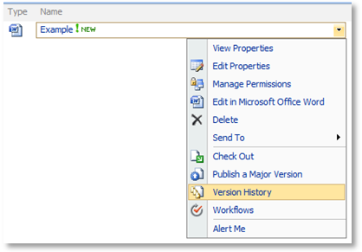
- To recover an earlier version, use Version History to display the options shown below.
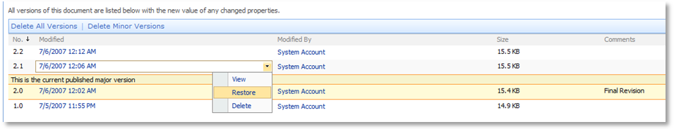
- Select the appropriate document version, click Restore, and then click OK.
The restored file is restored in the document library and placed at the top of the Version History list.

Recycle Bin
Recycle Bin settings are located in Central Administration under Application Management. Click Web Application General Settings to see the settings.
By default the Recycle Bin is turned on and stores items for 30 days.
The following diagram demonstrates the flow of events for deleted items in the first-stage Recycle Bin.
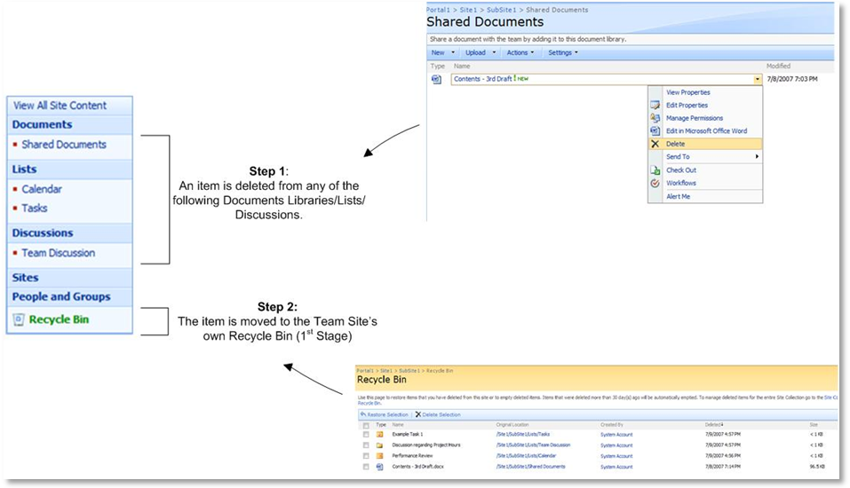

The following diagram demonstrates the flow of events for deleted items in the second-stage Recycle Bin.
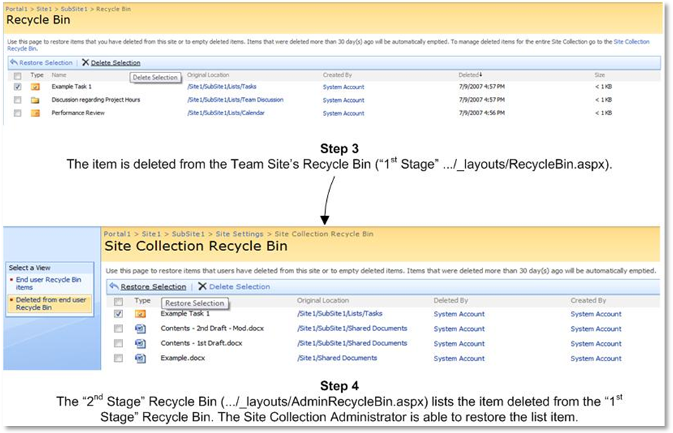

Note: The items view for the end user Recycle Bin is a feature of the Site Collection Recycle Bin page. It summarizes all the deleted items in the entire site collection. Administrators can visit this page to purge items to regain storage space, if required.

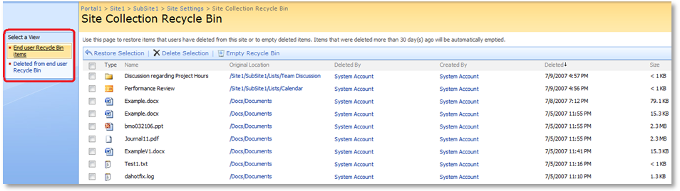

Site recovery
This section briefly describes how to use Office SharePoint Designer 2007, Microsoft IT Site Delete Capture 1.0, and a database snapshot to recover Web sites.

Use Office SharePoint Designer 2007 to back up a Web site
Backing up a Web site by using Office SharePoint Designer 2007 creates a content migration package, or .cmp file. When you back up a Web site, you can choose to back up either the top-level Web site or the top-level Web site and any subsites. The backup file that you create includes list or library content, security settings, user information, navigation, customizations, and personalizations (such as views, site templates, and content types). The backup file does not include workflows, alerts, and properties stored at the site-collection level.
To back up a site, you must have administrator permissions for that site, but you do not need administrative access to the server that is running Office SharePoint Server.
- In Office SharePoint Designer 2007, on the File menu, click Open Site.
- In the Open Site dialog box, browse to and click the Web site that you want to back up, and then click Open.
- On the Site menu, point to Administration, and then click Backup Web Site.
- In the Backup Web Site dialog box, to include all subsites of the current Web site in the backup, select the Include subsites in archive check box.
- If the current Web site is low on available storage space, click Advanced, specify a new location, and then click OK.
- Backing up a Web site requires a location to store temporary backup files. By default, Office SharePoint Designer 2007 uses the current Web site. You can use another site on the same server or a location on another server on the same network — for example, \\Server name\Share name.
- In the Backup Web Site dialog box, click OK.
- In the File Save dialog box, select the location where you want to store the .cmp file.
- In the File name box, type the name for the file, and then click Save.
- If the site that you are backing up or restoring is large, the process can take a long time.

Use Office SharePoint Designer 2007 to restore a Web site
Restoring a Web site from Office SharePoint Designer 2007 requires that you create a new empty Web site and then restore the backup file to that site.

Step 1: Create a new, empty Web site as a destination
- In Office SharePoint Designer 2007, on the File menu, click New.
- In the New dialog box, click the Web Site tab, click General, and then click Empty Web Site.
- In the Specify the location of the new Web site box, enter the location where you want to restore the backup site.
- You can restore the site to a different server, and you can restore it as either a new top-level site or a subsite under an existing top-level site.
- Click OK.

Step 2: Restore the backup file to the destination
- With the destination site open, on the Site menu, point to Administration, and then click Restore Web Site.
- In the File Open dialog box, browse to and click the .cmp file that you want to restore, and then click Open.
- In the Restore Web Site dialog box, click OK to confirm that you want to restore the .cmp file to the current empty Web site.
- If the site that you are backing up or restoring is large, the process can take a long time.

Use Microsoft IT Site Delete Capture 1.0 to capture and restore deleted Web sites
To use the Microsoft IT Site Delete Capture 1.0 tool, you must install the tool and then configure it by using the Stsadm command-line tool and enable it in Central Administration. Once the tool has been configured, any site that is deleted is saved as a .bak file and can be restored using the stsadm –o recovery operation.
For more information, see Codeplex governance (http://go.microsoft.com/fwlink/?LinkID=92682&clcid=0x409).

Create and view a database snapshot of an Office SharePoint Server content database
Note: this procedure assumes that you have a backup server running Office SharePoint Server.
- Use an account that is a member of the Administrators group on the computer that is running SQL Server 2005, and is a member of the db_owner fixed database role in SQL Server.
- Click Start, point to All Programs, click Microsoft SQL Server 2005, and then click SQL Server Management Studio.
- In the Connect to Server dialog box, click the options that you want, and then click Connect.
- In the database list, click the content database that you want.
- In the Microsoft SQL Server Management Studio MMC snap-in, click New Query.
- Copy the following text, and then paste it to the query pane. WSS_Content is the name of the content database that hosts the SharePoint site.
CREATE DATABASE WSS_Backup1
ON
(
NAME=WSS_Content,
FILENAME = 'c:\WSS_Backup1.ss')
AS SNAPSHOT OF <WSS_Content>;
- Click Execute to take a snapshot of the content database.
- On the backup computer, click Start, point to Administrative Tools, and then click SharePoint 3.0 Central Administration.
- On the Central Administration page, click Application Management.
- On the Application Management page, click Create or Extend Web Application.
- On the Create or Extend Web Application page, click Create a New Web Application.
- Next to Database Name and Authentication, specify in the database server field the name of the production database server that contains the WSS_backup1 database. When you complete this step, the backup server points to the snapshot database. To verify this, open the SharePoint site on the backup server to make sure that the site displays the information that you backed up. Changes to your production server do not affect the database snapshot.

Disaster recovery
This section describes how to use the tools that we recommend in a standard farm-level backup and recovery. It does not describe all possible uses of the backup and recovery tools. For more information about the Office SharePoint Server backup and recovery tools, see Administering backup and recovery for Office SharePoint Server 2007 (http://go.microsoft.com/fwlink/?LinkId=102627&clcid=0x409).

Backup procedures
The procedures in this section include:
- Back up a farm by using the Stsadm backup operation
- Monitor a backup by using Central Administration
- Back up databases by using SQL Server
- Document IIS and AAM settings
- Back up customizations by using Windows Server Backup
Note: This section does not include information about how to back up when you are using System Center Data Protection Manager. For information about installing, deploying, and configuring DPM to protect a SharePoint farm, see System Center Data Protection Manager 2007 (http://go.microsoft.com/fwlink/?LinkId=102807&clcid=0x409).

Back up a farm by using the Stsadm backup operation
The Stsadm command-line tool offers the option to back up an entire farm, a site collection, or an item. You can also schedule Stsadm backups by using the Windows Task Scheduler.
Syntax for farm-level backup
stsadm -o backup
-directory <UNC path or local drive>
-backupmethod <full or differential>
[-item] <created path from tree>
[-percentage] <integer between 1 and 100>
[-backupthreads] <integer between 1 and 10>
[-showtree]
[-quiet]
Syntax for site collection backup
stsadm -o backup
-url <URL name>
-filename <file name>
[-overwrite]
Note: Before you perform a site collection backup, you should Read/Write lock the site so that it cannot be accessed during the backup operation.
For more details, see Backup: Stsadm operation (Office SharePoint Server) (http://go.microsoft.com/fwlink/?LinkId=102628&clcid=0x409).
The following example uses the backup operation to perform a farm-level backup:
stsadm -o backup \\servername\foldername -backupmethod full
The result of this backup command is shown below.
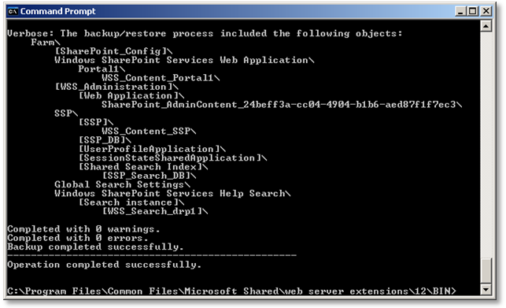
You can also name a specific object to back up. To identify objects that can be backed up, view the backup tree by using the Stsadm showtree option:
stsadm -o backup -showtree -item "SharePoint"

You can back up only a single item (and all of its children) in the backup tree at a time.

Create a batch file to run a full Stsadm backup
To create a batch file to run Stsadm backups, you should create a batch file that runs the type of backup you want and sets any options that you would like to have.
We recommend that you create at least two batch files—one to run full backups, and one to run weekly backups.
- To open Notepad, click Start, click All Programs, point to Accessories, and then click Notepad.
- Type the Stsadm backup command to run a full farm backup, with the options that you want.
The following example performs a full backup:
%COMMONPROGRAMFILES%\Microsoft Shared\Web Server Extensions\12\bin\stsadm -o backup -directory \\server\foldername -backupmethod full
- Save the file with a name that indicates that this is the batch file to run for full backups, for example “SharePointServer_FULL.BAT”.

Create a batch file to run a differential Stsadm backup
- Open Notepad, and then type the Stsadm backup command to run a differential farm backup, with the options that you want.
The following example performs a differential backup:
%COMMONPROGRAMFILES%\Microsoft Shared\Web Server Extensions\12\bin\stsadm -o backup -directory \\server\foldername -backupmethod differential
- Save the file with a name that indicates that this is the batch file to run for differential backups, for example “SharePointServer_DIFF.BAT”.

Schedule Stsadm backups by using Windows Task Scheduler:
To open your list of scheduled tasks, click Start, click All Programs, point to Accessories, point to System Tools, and then click Scheduled Tasks.
- Double-click Add Scheduled Task to start the Scheduled Task Wizard, and then click Next.
- In the next dialog box, click Browse, and then navigate to your full backup batch file.
- By default, the task is named for the filename you entered—you can enter a different name for the task. Choose one of the following options to set how often to run it. We recommend that you perform full backups at least weekly until you have analyzed your system usage:
- Daily
- Weekly
- Monthly
- One time only
- When my computer starts (before a user logs on)
- When I log on (only after the current user logs on)
- Click Next, specify a day and time to run the task, and then click Next again.
- Enter the name and password of the user to run the task as. Make sure that you choose a user account that has sufficient permissions to perform the backup operation. By default, the wizard selects the name of the user who is currently logged on.
- Click Next, and then click Finish after you verify the choices that you have made.
- Repeat Steps 1-6 for your differential backup file.

Monitor a backup by using Central Administration
Backups performed using the Stsadm command-line tool can be monitored by using Central Administration. While a job is running, it appears on the Backup and Restore Status page, which is available from the Operations page. After a job has finished, it appears on the Backup and Restore History page (which is also available from the Operations page). Administrators can select backups to restore from this page.

Back up databases by using SQL Server
You can add the SQL Server databases used by Office SharePoint Server to your existing SQL Server backup strategy. This paper assumes that you have an existing backup strategy that you are going to add your Office SharePoint Server databases to. If you are interested in setting up a new SQL Server backup strategy, see Backing Up and Restoring Databases in SQL Server (http://go.microsoft.com/fwlink/?LinkId=102629&clcid=0x409).

If you are performing both SQL Server database backups and farm backups using the Stsadm command-line tool, we recommend that you schedule the database backups before the Stsadm backups because Stsadm -directory backups truncate the SQL Server log.

Document alternate access mapping settings
If you are using alternate access mappings, we recommend that you export your AAM settings to a text file by using the command stsadm -o enumalternatedomains and then back up the text file by using the Windows Server 2003 Backup tool or another file backup system. The following example writes the AAM settings for the Contoso site to a text file on drive C.
stsadm -o enumalternatedomains -url http://contoso:1234 > c:\aambackup.txt

Document IIS settings
For each front-end Web server and Web application on your farm, document your IIS settings and any others that you modified outside of Office SharePoint Server. A partial list of settings includes:
- SSL certificate
- Host header
- IP address binding
For more information about documenting and saving IIS configurations, see Saving Configurations (IIS 6.0) (http://go.microsoft.com/fwlink/?LinkId=102632&clcid=0x409).

Back up customizations by using the Windows Server 2003 Backup tool
This procedure assumes that you are scheduling only the backup of the 12 hive on a computer. Perform this task on all front-end Web servers.
- Click Start, point to Accessories, point to System tools, and then click Backup.
The Backup or Restore Wizard appears.
- On the first page of the wizard, click the Advanced Mode link.
- On the Backup tab, select the 12 hive: Program Files\Common Files\Microsoft Shared\Web server extensions\12.
- Select File or a tape device in Backup destination.
- In Backup media or file name, type a path and file name for the backup file, or select a tape.
- Select any backup options you want, such as the backup type and the log file type, by clicking the Tools menu and then clicking Options. When you have finished selecting backup options, click OK.
- On the Job menu, select Save Selections to save your selections as a backup job file (.bks).
- Click Start Backup and click Schedule in the Backup Job Information dialog box.
- In the Set Account Information dialog box, specify the user name and password that you want the scheduled backup to run under.
- In the Scheduled Job Options dialog box, in Job name, type a name for the scheduled backup job, and then click Properties on the Schedule data tab to set the date, time, and frequency parameters for the scheduled backup. When you have finished, click OK, and then click OK again.

Recovery procedures
The procedures in this section include:
- Restore a farm by using Central Administration
- Restore application server roles
- Restore front-end Web servers
- Restore content or SSP databases
- Restore customizations by using the Windows Server Backup tool
Note: This section does not include information about how to recover when you are using System Center Data Protection Manager. For information about using DPM to recover content items, sites, and farms. see:
- How to Recover a Windows SharePoint Services Item (http://go.microsoft.com/fwlink/?LinkId=102815&clcid=0x409)
- How to Recover a Windows SharePoint Services Site (http://go.microsoft.com/fwlink/?LinkId=102826&clcid=0x409)
- How to Recover a Windows SharePoint Services Farm (http://go.microsoft.com/fwlink/?LinkId=102831&clcid=0x409)

- For more information, see White paper: Microsoft Office SharePoint Server 2007 Search Backup for DPM 2007 (http://go.microsoft.com/fwlink/?LinkId=116263&clcid=0x409).

The procedures below assume that you may be restoring to a different location within a farm, or to another farm. To restore to a different location, you need a separate installation of Office SharePoint Server to create a functioning configuration database and SharePoint Central Administration Web site and database.

Restore a farm by using Central Administration
This section describes the process for recovering from a farm-level failure. For the procedures in this section, we assume that you are restoring a three-tier server farm consisting of a database server, an application server that provides Index, Query, InfoPath Forms Services and Excel Calculation Services, and two front-end Web servers that service search queries and provide Web content.

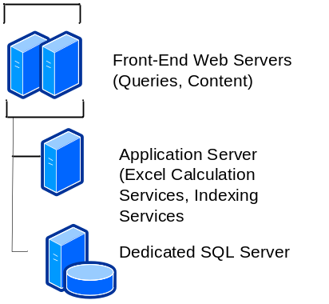
The following diagram describes the recovery process for a farm.
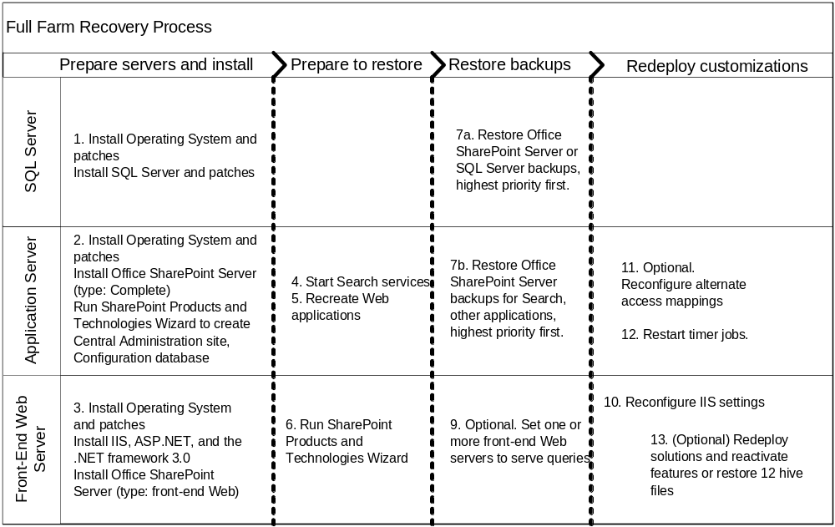

Overview of a farm-level recovery that uses Central Administration
- Rebuild database servers.
- Install Windows Server 2003, SQL Server 2000 or SQL Server 2005 and software updates.
- Rebuild application servers.
- Install Windows Server 2003and .NET Framework 3.0.
- Install Office SharePoint Server 2007 (Type: Complete)
- Rebuild front-end Web servers.
- Install Windows Server 2003, IIS, ASP.NET, and the .NET Framework 3.0.
- Install Office SharePoint Server 2007 (Type: front-end Web)
- Run the SharePoint Products & Technologies wizard on the application server.
- Start Search services.
- Re-create your Web applications.
- Run the SharePoint Products and Technologies Wizard on the front-end Web servers.
- Restore the Office SharePoint Server farm backup.
- Set one or more front-end Web servers to serve queries.
- Reconfigure IIS settings.
- (Optional) Reconfigure alternate access mappings.
- Start timer jobs.
- (Optional) On all front-end Web servers, redeploy solutions and reactivate features or restore the 12 hive using the Windows Server 2003 Backup tool.
The procedures in this section assume that the Windows Server 2003 platform has been installed on all servers, and that all software updates have been applied to all servers. The procedures assume that IIS and ASP.NET have been installed on the front-end Web servers. They also assume that you have rebuilt your database servers.

Enable ASP.NET v2.0.50727 in IIS Manager
Perform this procedure on all front-end Web servers.
  - Click Start, point to All Programs, point to Administrative Tools, and then click Internet Information Services (IIS) Manager.
  - In the Internet Information Services tree, click the plus sign (+) next to the server name, and then click the Web Service Extensions folder.
  - In the details pane, right-click ASP.NET v2.0.50727, and then click Allow.

Install .NET Framework 3.0
Perform this procedure on the application server and all front-end Web servers.
Go to the Microsoft Download Center Web site (http://go.microsoft.com/fwlink/?LinkID=72322&clcid=0x409), and on the Microsoft .NET Framework 3.0 Redistributable Package page, follow the instructions for downloading and installing .NET Framework version 3.0. There are separate downloads for x86-based computers and x64-based computers. Be sure to download and install the appropriate version for your computer. The .NET Framework version 3.0 download contains the Windows Workflow Foundation technology, which is required by workflow features in Office SharePoint Server.

Install Microsoft Office SharePoint Server 2007
Perform this procedure on the application server.
- From the product disc, run Setup.exe.
- Enter your product key in the field provided. Click Continue.
- On the Read the Microsoft Software License Terms page, review the terms, select I accept the terms of this agreement, and then click Continue.
- On the Choose the installation you want page, click Advanced.
- On the Server Type tab, select Complete.
- On the File Location tab, fill in the paths according to your original configuration.
- Finish the installation.
- When Setup finishes, a dialog box prompts you to complete the configuration of your server. Be sure that the Run the SharePoint Products and Technologies Configuration Wizard now check box is selected.
- Click Close to start the Configuration wizard.
Do not complete the Configuration wizard until you have installed Office SharePoint Server on all servers. See the next section.

Perform this procedure on the front-end Web servers.
- From the product disc, run Setup.exe.
- Enter your product key in the field provided. Click Continue.
- On the Read the Microsoft Software License Terms page, review the terms, select I accept the terms of this agreement, and then click Continue.
- On the Choose the installation you want page, click Advanced.
- On the Server Type tab, select Front End Web.
- On the File Location tab, fill in the paths according to your original configuration.
- Finish the installation.
- When Setup finishes, a dialog box prompts you to complete the configuration of your server. Be sure that the Run the SharePoint Products and Technologies Configuration Wizard now check box is selected.
- Click Close to start the configuration wizard.
Do not complete the Configuration wizard on the front-end Web servers until you have installed Office SharePoint Server on all servers, and re-created your Web applications. See the next section.

Run the SharePoint Products and Technologies Configuration Wizard (Application Server)
The SharePoint Central Administration Web site is installed by default on the first server on which you install Office SharePoint Server 2007. In this scenario, we have decided to install Central Administration on the application server.
Complete the following procedure on the application server.
- On the Welcome to SharePoint Products and Technologies page, click Next.
- In the dialog box that notifies you that some services might need to be restarted or reset during configuration, click Yes.
- On the Connect to a server farm page select No, I want to create a new server farm, and then click Next.
- On the Specify Configuration Database Settings page, fill in the field with the settings from your original configuration, and then click Next.
- On the Configure SharePoint Central Administration Web Application page, enter a port number, select an authentication provider, and then click Next.
Note: For ease of administration we recommend that you select a port number that is easy to remember (such as 50000)
- Verify the settings on the Completing the SharePoint Products and Technologies Configuration Wizard page, and then click Next.
The Configuration Successful page appears.
- Click Finish.
The Central Administration home page opens.

Start the Search services
Complete the following procedure on the application server.
- Open Central Administration, and on the Operations tab, in the Topology and Services section, click Services on Server.
- Select the application server in the Server field.
- Start the Windows SharePoint Services Search Service.
- Fill in all credential fields and the search database name according to your original configuration, and then click Start.

Complete the following procedure for the application server.
- Open Central Administration, and on the Operations tab, in the Topology and Services section, click Services on Server.
- Select the application server in the Server field.
- Start the Office SharePoint Server Search Service.
- Select the Use this server for indexing content and check boxes.
- Fill in the remaining fields as required, and then click Start.

Re-create your Web applications
You must re-create all Web applications for your farm before you restore, so that the timer jobs associated with each Web application are created.
- Click the Start button, point to All Programs, then point to Microsoft Office Server, and then click SharePoint 3.0 Central Administration.
- On the Central Administration home page, click Application Management.
- On the Application Management page, in the SharePoint Web Application Management section, click Create or extend Web application.
- On the Create or Extend Web Application page, in the Adding a SharePoint Web Application section, click Create a new Web application.
- On the Create New Web Application page, enter the settings you used previously.
For more information, see Create or extend Web applications (http://go.microsoft.com/fwlink/?LinkId=102634&clcid=0x409).

Run the SharePoint Products and Technologies Configuration Wizard (front-end Web servers)
Complete the following procedure on the front-end Web servers.
- On the Welcome to SharePoint Products and Technologies page, click Next.
- In the dialog box that notifies you that some services might need to be restarted or reset during configuration, click Yes.
- On the Connect to a server farm page, select Yes, I want to connect an existing server farm, and then click Next.
- On the Specify Configuration Database Settings page, fill in the field with the settings from your original configuration, and then click Next.
- Verify the settings on the Completing the SharePoint Products and Technologies Configuration Wizard page, and then click Next.
The Configuration Successful page appears.
- Click Finish.
At this point, regardless of which server you log onto, you will be running the Central Administration site from the application server.

Restore the Office SharePoint Server farm backup (Central Administration)
Important: In an environment that includes multiple front-end Web servers, the farm administration account must also be an administrator on the local computer in order for recovery to succeed.
Note: You can also perform this step by using the stsadm restore operation. For more information about this operation, see Restore: Stsadm operation (Office SharePoint Server) (http://go.microsoft.com/fwlink/?LinkId=102635&clcid=0x409).

- Open Central Administration, and on the Operations tab, in the Backup and Restore section, select Restore from Backup.
- On the Step 1: Select Backup Location page, under Backup File Location, specify the path to the backup folder.

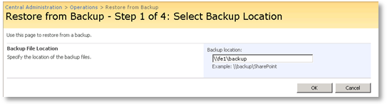

- On the Step 2: Select Backup to Restore page, select the backup package to restore, and then click Continue Restore Process.

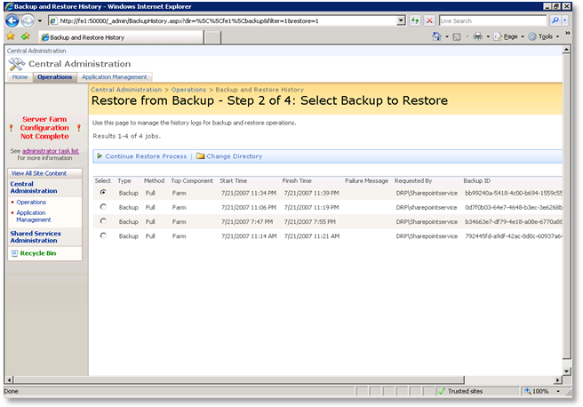
- On the Step 3: Select Component to Restore page, select the items to restore (Farm, Service, Database, or SSP), and then click Continue Restore Process.
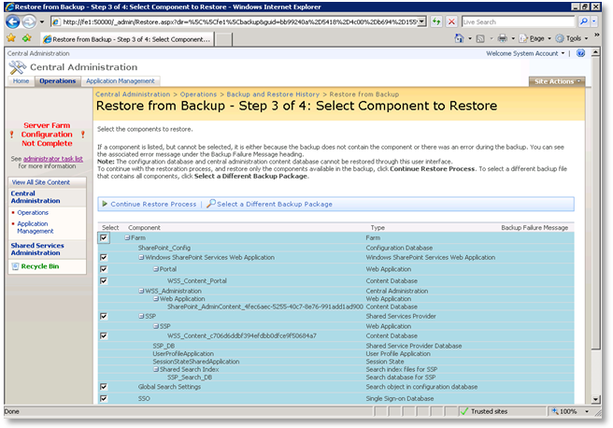
- On the Step 4: Select Restore Options page, click Same Configuration, and then click OK.
- A warning appears. Click OK to dismiss it.

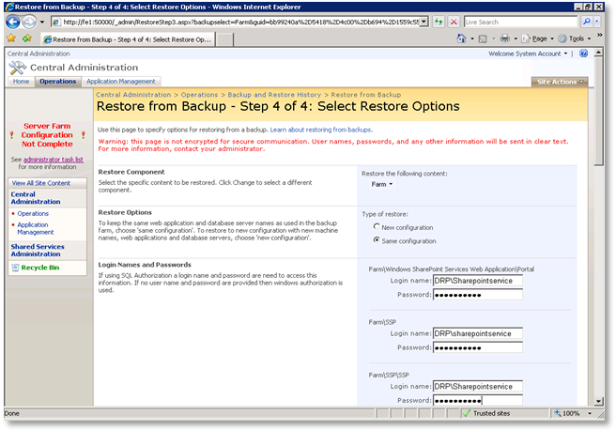

- The Backup and Restore Status page appears. This page is refreshed every 30 seconds. The recovery can take a few minutes to start.
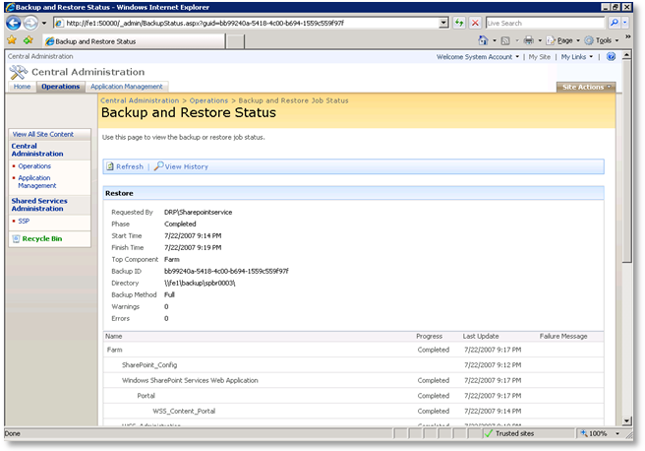
- When the recovery has successfully finished, restart IIS.
If there are errors in the recovery process, they will be listed in the UI.
Note: A log file for each recovery (sprestore.log) is created under the backup folder. It contains detailed events and messages from the recovery procedure.
- If your system was successfully restored, verify that it works correctly.

Note: To restore the system again, the earlier Backup/Restore job must be deleted from the Timer Job Definitions page, which is available from the Operations page.

Set one or more front-end Web servers to serve queries
Complete the following procedure for the front-end Web server that you want to act as a query server.
- Open Central Administration, and on the Operations tab, in the Topology and Services section, click Services on Server.
- Select the front-end Web server in the Server field. In the Start services in the table below field, select Office SharePoint Server Search, and then select Use this server for serving search queries, and then click OK.
After the farm is restored, the search index is copied to the query server.

Reconfigure IIS settings
For each front-end Web server, configure any IIS settings required by your system. Settings may include SSL certificates, IP address bindings, and host header entries. For information about how to restore and configure SSL bindings in host headers, see Restore SSL bindings for host headers.

(Optional) Re-create alternate access mappings
- On the top navigation bar, click Operations.
- On the Operations page, in the Global Configuration section, click Alternate access mappings.
- Refer to the text file that you created with the stsadm -o enumalternatedomains option to re-create your mappings.

Start timer jobs
Some timer jobs are not started when you create a Web application and restore the Web application backup. Use the following procedure to start the required timer jobs. You must repeat steps 2 and 3 of the following procedure for all Web applications. For more information, see Some SharePoint timer job definitions are not restored successfully when you back up a Windows SharePoint Services Web application or a Microsoft Office SharePoint Server 2007 Web application, and then you restore this application to a new farm ) (http://go.microsoft.com/fwlink/?LinkId=102639&clcid=0x409).
- Create a new Publishing Portal site collection in the target farm. (This action automatically creates the following timer job definitions.) Then delete the temporary Publishing Portal site collection that you created. The timer job definitions will remain active.
Scheduled Approval (ApprovalJobDefinition)
Scheduled Page Review (NotificationJobDefinition)
Variations Propagate Page Job Definition (PropogateVariationPageJobDefinition)
Variations Propagate Site Job Definition (SpawnSitesJobDefinition)
Scheduled Unpublish (UnpublishJobDefinition)
- After you restore each Web application, run stsadm -o setbulkworkflowtaskprocessingschedule at the command prompt on the application server to start the Bulk workflow task processing (BulkWorkflowWIJD) job.
- After you restore each Web application, run stsadm -o setsearchandprocessschedule at the command prompt on the application server to start the Search and Process (SearchAndProcessWIJD) job.

(Optional) Redeploy solutions and reactivate features or restore the 12 hive
In a customized environment, you must either redeploy your solutions and reactivate features, or restore a backup of the 12 hive on all front-end Web servers.
Redeploy a solution
If you have a solution package that you want to redeploy, use the Stsadm deploysolution option. This example uses the -allcontenturls parameter to deploy the solution to all site collections within the farm.
stsadm -o deploysolution -name mysolution.wsp -allcontenturls
For more information about deploying solutions, see Development Tools and Techniques for Working with Code in Windows SharePoint Services 3.0 (Part 2 of 2) (http://go.microsoft.com/fwlink/?LinkId=102644&clcid=0x409).
Reactivate features
If your solution contains features that must be activated, activate the features at the appropriate level (Web application, site collection, or Web site).To activate a feature, you can navigate to the administrative interface for the appropriate object, or run the following command, specifying the URL of the Web application, site collection or site:
stsadm -o activatefeature -name < folder in FEATURES directory containing the Feature.xml file > -url http://Server/Site/Subsite

Restore a backup of Program Files\Common Files\Microsoft Shared\Web server extensions\12
This procedure assumes that you are restoring only the backup of the 12 hive on a computer. Only use this procedure if your customizations are not packaged as solutions.
- Click Start, point to Accessories, point to System tools, and then click Backup.
The Backup or Restore Wizard opens.
- Click the Advanced Mode link on the Backup or Restore Wizard.
- Click the Restore and Manage Media tab, select the files and folders you want to restore by clicking the box to the left of the 12 hive: Program Files\Common Files\Microsoft Shared\Web server extensions\12.
- In Restore files to, click Original location.
- Click Start Restore.
- If you want to change any of the advanced recovery options, such as restoring security settings and junction point data, click Advanced. When you are done setting advanced recovery options, click OK.
- Click OK to start the recovery operation.

Restore application server roles
If one of the application servers in your farm fails, you can restore it from a full-farm backup. The steps in restoring an application server include:
- Prepare a new server.
- Re-create your Web application.
- Restore the Web application.
- Start the Search service.
- Start the timer jobs.
The following diagram describes the recovery process for an application server.
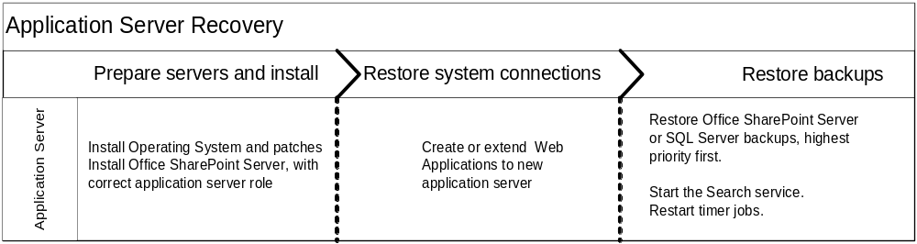

Prepare a new server
For details about how to prepare and install an application server, see:
- Prepare the Web and application servers (http://go.microsoft.com/fwlink/?LinkId=102796&clcid=0x409).
- Install Office SharePoint Server 2007 and run the SharePoint Products and Technologies Configuration Wizard (http://go.microsoft.com/fwlink/?LinkId=102797&clcid=0x409).

Considerations when restoring an index server
To restore an index server, in Step 3, "Restore the Web application," you must restore the SSP associated with the index.

Restore an SSP
- Open Central Administration, and on the Operations tab, in the Backup and Restore section, select Restore from Backup.
- On the Step 1: Select Backup Location page, under Backup File Location, specify the path to the backup folder.
- On the Step 2: Select Backup to Restore page, select the most recent backup package to restore, and then click Continue Restore Process.
- On the Step 3: Select Component to Restore page, select the SSP to restore and then click Continue Restore Process.
- On the Step 4: Select Restore Options page, click Same Configuration, and then click OK. Click OK again in the Warning dialog box.
- The Backup and Restore Status page appears. This page is refreshed every 30 seconds. The recovery can take a few minutes to start.
Note: If either the content index or search database recovery process is not successful, you must reset the index and perform a full crawl before search and indexing will work.

Considerations when restoring a query server
Dedicated query servers are automatically restored after a server or server farm failure if they retain the same name. If a query server is not working, remove the server from the farm, and then add it to the farm again and place it back in the query role. For information about setting a server to run the query role, see Deploy in a simple server farm (Office SharePoint Server) (http://go.microsoft.com/fwlink/?LinkId=102798&clcid=0x409).

Considerations when restoring other application servers
To restore other application servers, prepare each server and add it to the farm. In Central Administration, use the Services on Server page (available from the Operations page) to associate each server with the services you want.

Restore front-end Web servers
If one of the Web servers in your farm fails, reinstall it and then redeploy or replace your customizations.
The following figure describes the recovery process for a front-end Web server.
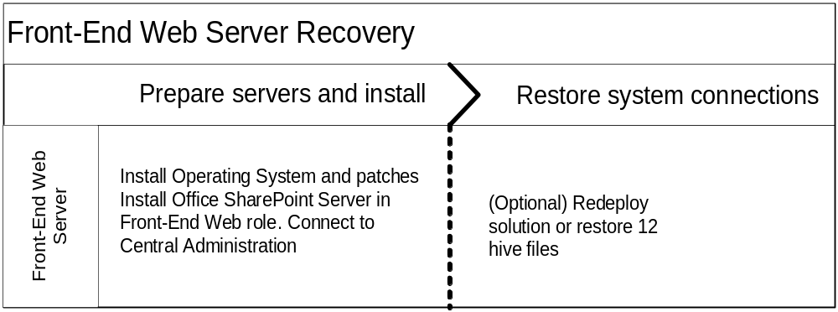

- Prepare a new server. For details about how to prepare and install a front-end Web server, see Prepare the Web and application servers (http://go.microsoft.com/fwlink/?LinkID=102796&clcid=0x409).
- Install Office SharePoint Server 2007 and run the SharePoint Products and Technologies Configuration Wizard to connect to the existing farm (http://go.microsoft.com/fwlink/?LinkID=102797&clcid=0x409).
- If you had customizations, redeploy your solution and activate any needed features, or restore the 12 hive. For more information, see Redeploy solutions and reactivate features or restore the 12 hive.
- In Central Administration, on the Operations tab, click Services on Server and associate the server with any services that you previously had running on the server.
- When restoring Web applications that use Host headers with SSL bindings, the bindings may need to be configured manually. For more information, see Restore SSL bindings for host headers.

Restore SSL bindings for host headers
If your sites, site collections, and Web applications use host headers in an SSL environment, the SSL bindings might not be configured properly after restoration, If necessary, you can manually restore the SSL bindings in your host headers. You must be a member of the Administrators group on the local computer to run scripts and executables.
At a command prompt, type the following command and then press ENTER:
cscript.exe adsutil.vbs set /w3svc/<site identifier>/SecureBindings ":443:<host header>"
where host header is the host header for the Web site, For example: site2.contoso.com or site4.contoso.com. For more information, see Configuring SSL Host Headers (http://go.microsoft.com/fwlink/?LinkId=128122).

Restore content or SSP databases
You can use either Office SharePoint Server or SQL Server backups to restore databases.
The following figure describes the recovery process for a database.
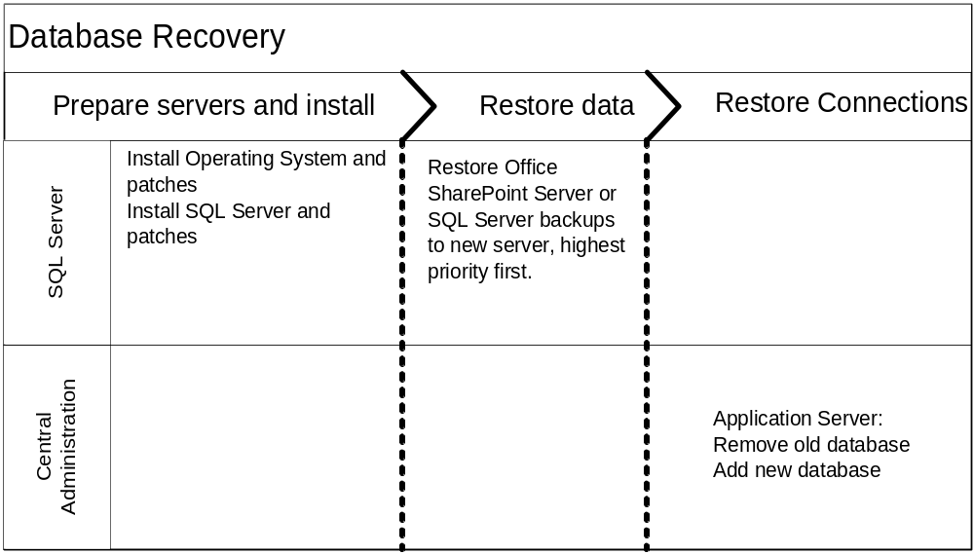

Recover a content or SSP database by using Office SharePoint Server backups
If the database server running a content database or SSP database fails, you can restore the databases by using Central Administration. This procedure assumes that you have a new database server with a different name correctly configured to work with Office SharePoint Server.
- Open Central Administration, and on the Operations tab, in the Backup and Restore section, select Restore from Backup.
- On the Step 1: Select Backup Location page, under Backup File Location, specify the path to the backup folder.
- On the Step 2: Select Backup to Restore page, select the most recent backup package to restore, and click Continue Restore Process.
- On the Step 3: Select Component to Restore page, select the database to restore and then click Continue Restore Process.
- On the Step 4: Select Restore Options page, click New Configuration, and then enter the new database server, new directory, and new database name.
- The Backup and Restore Status page appears.
- After the recovery job has finished, on the Application Management tab, in the SharePoint Web Application Management section, click Content Databases.
- In the Web Application field, verify that the correct Web application is selected.
- In the Database Name list, click the database that failed.
- Select the Remove content database check box, and then click OK.
- A warning that you are deleting a site collection appears. Click OK to dismiss it.
- On the Manage Content Databases page, click Add a content database, and then select the appropriate Web application to associate the database with. Specify the correct database server, database name, authentication settings, and capacity settings, and then click OK.

Recover a database by using SQL Server backups
If the database server running a content database or SSP database fails, you can restore the database by using SQL Server backups. This procedure assumes that you have a new database server with a different name correctly configured to work with Office SharePoint Server, and that you have restored the Office SharePoint Server databases to the new SQL Server.
- Open Central Administration, and on the Application Management tab, in the SharePoint Web Application Management section, click Content Databases.
- In the Web Application field, verify that the correct Web application is selected.
- In the Database Name list, click the database that failed.
- Select the Remove content database check box, and then click OK.
- A warning that you are deleting site collections appears. Click OK to dismiss it.
- On the Manage Content Databases page, click Add a content database, and then select the appropriate Web application to associate the database with. Enter the correct database server, database name, authentication settings, and capacity settings, and then click OK.

Summary
We hope that this paper has given you an understanding of the options and recommended practices for backup and recovery for Office SharePoint Server deployments. For more information about backing up and restoring Office SharePoint Server, see:
- Plan for backup and recovery (Office SharePoint Server) (http://go.microsoft.com/fwlink/?LinkId=102799&clcid=0x409)
- Administering backup and recovery for Office SharePoint Server 2007 (http://go.microsoft.com/fwlink/?LinkID=102627&clcid=0x409)
You may also want to investigate the following technologies:
- Solutions built on Volume Shadow Copy Service (VSS).
The Volume Shadow Copy Service (VSS) was introduced in Windows XP and Windows Server 2003. VSS is a framework facilitating communication between applications, storage subsystems, and storage management applications (including backup applications). This framework enables you to define, persist, and exploit point-in-time copies of storage data. The Windows SharePoint Services VSS Writer is a new service in Windows SharePoint Services 3.0 and in the server products in the 2007 Office release. This writer service enables a requestor (http://go.microsoft.com/fwlink/?LinkId=90911&clcid=0x409) to ask a front-end Web server to provide a VSS backup (full or differential), and Windows SharePoint Services then points the requestor to the SQL databases and the Search Index to be backed up by using VSS. For more information about VSS, see the MSDN article Volume Shadow Copy Service (http://go.microsoft.com/fwlink/?LinkId=90912&clcid=0x409). The Volume Shadow Copy Service SDK 7.2 (http://go.microsoft.com/fwlink/?LinkId=90914&clcid=0x409) is available on the Microsoft Download Center.
- Third-party solutions built on technologies supported by Microsoft, such as VSS. To find third-party solutions built by Microsoft partners, visit Solution Finder (http://go.microsoft.com/fwlink/?LinkId=102834&clcid=0x409) and search for
- Solution type = Software Offering
- Product category = Microsoft Office 2007 System
- Product = Microsoft Office SharePoint Server 2007
- Keywords: SharePoint Backup Restore Disaster Recovery

Microsoft partners that provide disaster-recovery solutions for Office SharePoint Server include:
  - AvePoint (http://www.avepoint.com/products)
  - Commvault (http://www.commvault.com/solutions/sharepoint)
  - Neverfail (http://www.neverfailgroup.com/products/app-modules/sharepoint.aspx)
  - Quest: (http://www.quest.com/documents/landing.aspx?id=5153)
For highly-available environments, we recommend that you review Plan for availability (Office SharePoint Server) (http://go.microsoft.com/fwlink/?LinkId=102835&clcid=0x409) and then investigate the use of the following tools and technologies that provide redundancy:
- SQL Server database failover clustering
Failover clustering in Microsoft SQL Server 2005 provides high-availability support for an entire SQL Server instance. For example, you can configure a SQL Server instance on one node of a failover cluster to fail over to any other node in the cluster during a hardware failure, operating system failure, or a planned upgrade. For more information, see Failover Clustering (http://go.microsoft.com/fwlink/?LinkId=102837&clcid=0x409) in SQL Server 2005 Books Online.
- SQL Server database mirroring
In database mirroring, transactions are sent directly from a principal database and server to a mirror database and server whenever the principal database’s transaction log buffer is written to disk. This technique can keep the mirror database nearly up to date with the principal database. You can optionally use a third server, a witness server, to enable automatic failover from the principal server to the mirror server. For more information, see the white paper named Using database mirroring (Office SharePoint Server) (http://go.microsoft.com/fwlink/?LinkId=83725&clcid=0x409).
- Network Load Balanced clusters
Network Load Balancing provides failover support for IP-based applications and services that require high scalability and availability. Network Load Balancing can run on all editions of Windows Server 2003. For more information, see Windows Server 2003 Network Load Balancing (NLB) (http://go.microsoft.com/fwlink/?LinkId=102838&clcid=0x409).

