Dental Procedures and Dental Office Overview

Front Office

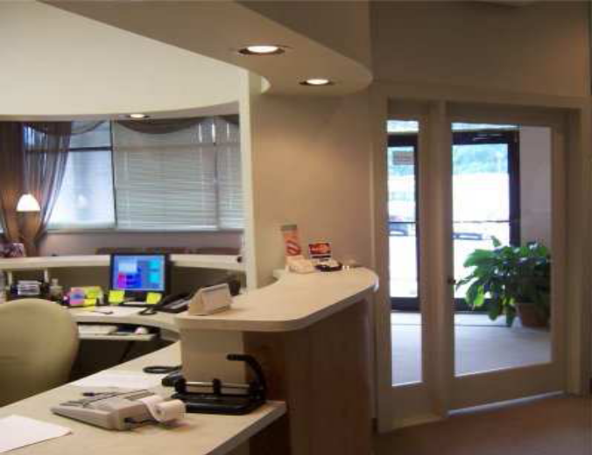

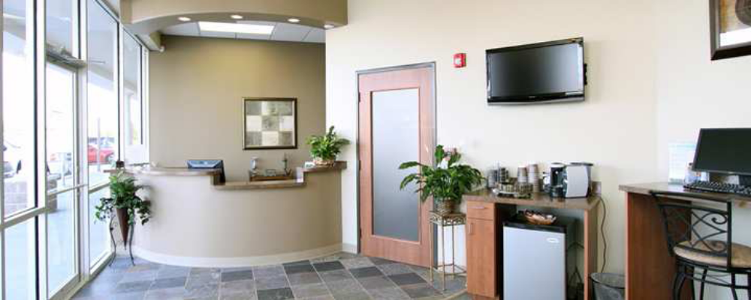

Receptionists or Office Manager workstation

Patient Files / folders – vs Electronic processing, fights off sales people
File contains paper records and film image than have to be scanned to go “Digital”
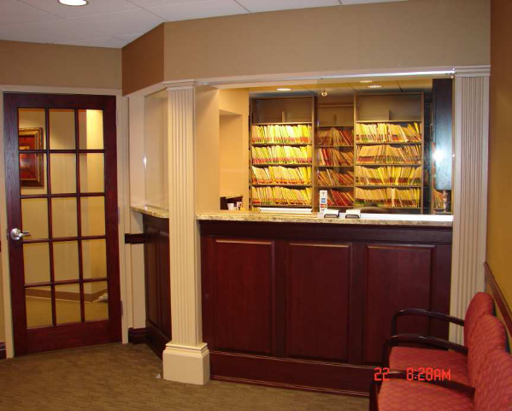


Greets patients, schedules appointments, etc..

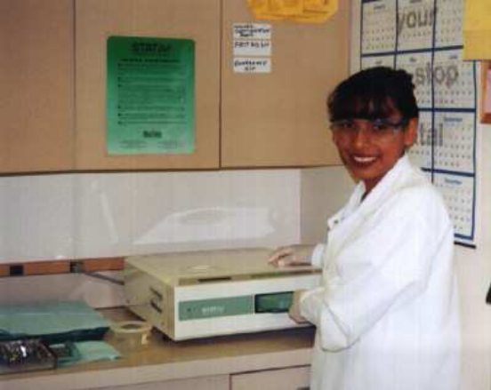
Backoffice staff
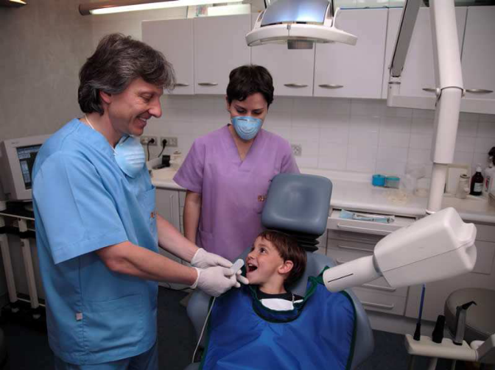

Enclave
(sterilizes tools, etc..)
Sensor, Analogue X-ray, Lead lines walls and patient, technician were lead apron.

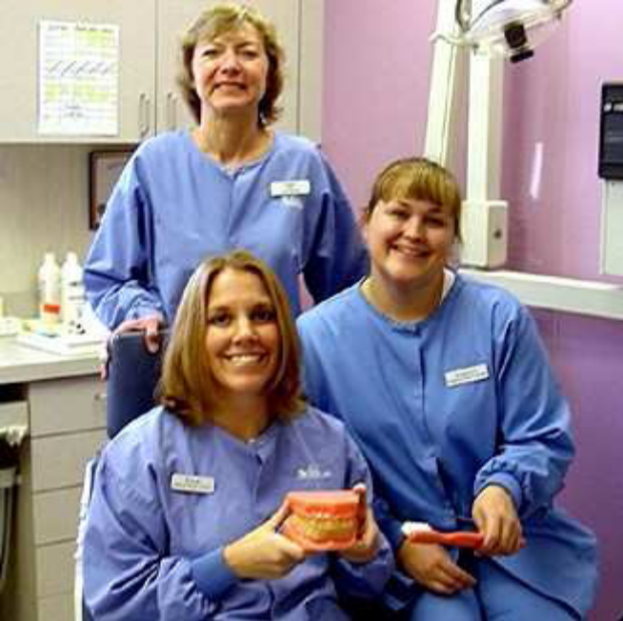
Loupes – Magnifies the view




