Mvision Create a Report

Table of contents
- Create a Report
- Schedule a Report
You can create a new report on the following pages:
- Services Overview
- Users Overview
- Policy Incidents Summary
- Policy Incidents
- My Dashboard

Create a Report
A report takes the name and parameters from the details of the page from which it is run.
- Select Actions.
- Under Create Report, select the report Format (if available).
The report runs immediately and is emailed to the user. You may also view the report in Report Manager.

Schedule a Report
To schedule a report:
- Search for your data via the Omnibar, select a date range using the Date Picker, and select filters or Saved Views as needed.
- Select Actions > Schedule.
- In the Schedule Report dialog, enter the following information:
  - Report Name. Define a report name to identify the report for future access.
  - Description. (Optional.) Enter a description of the report and its purpose.
  - Filters. Click the + to display the date range and filters that you selected, and any Data Jurisdictions that may apply.
  - File Format. Select one file type you'd like to use for the report. If you'd like reporting on more than one file type, create another report.
    - Analytic Report (XLSX)
    - Raw Data (CSV)
    - Business Report (PDF)
Note:
PDF reports are limited to 20,000 rows in a table. If your table includes more than 20,000 rows, the PDF report will be truncated. You can edit the table to reduce the number of columns.

For reports that have long, multi-lined fields such as External Collaborators, those fields may be truncated. In general, for large reports, use the XLSX or CSV format. Also, charts are only available in PDFs reports.
  - Group By. (Optional.) Select one Group By setting, and then choose up to 10 additional options to group data in your report. (If you select the All Data or All Services options, all other options will be greyed out.)
  - Frequency. Select a frequency to run the report:
    - Daily. Select hour, minutes, AM or PM, and UTC or another timezone.
    - Weekly. Select every number of week(s), on the day of the week, hour, minutes, AM or PM, and UTC or another timezone.
    - Monthly. Select the first, second, third, fourth or last day of every number of month(s), hour, minutes, AM or PM, and UTC or another timezone
  - Recipients. Enter the email addresses of anyone to which you would like to automatically email the report. Separate email addresses with commas.
  - Share report with other users within your MVISION Cloud account. Select this option to make the report public within your organization.
- Click Schedule.
The report is run as scheduled. You can view and manage existing reports on the Reports > Report Manager page.
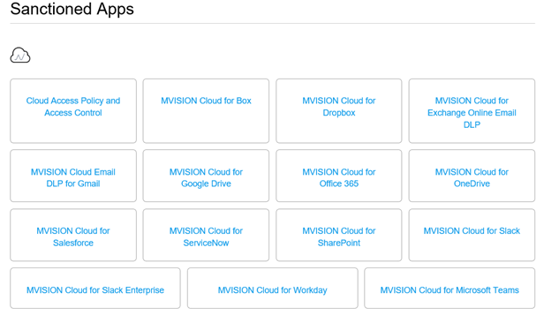

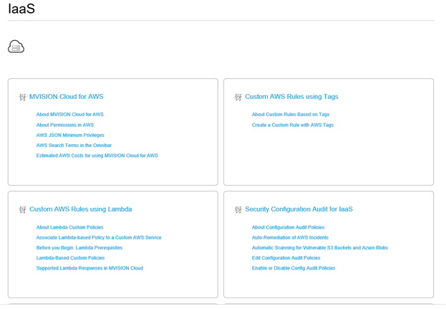

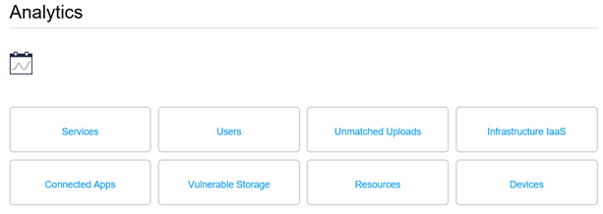

Report Manager 6/15/2023
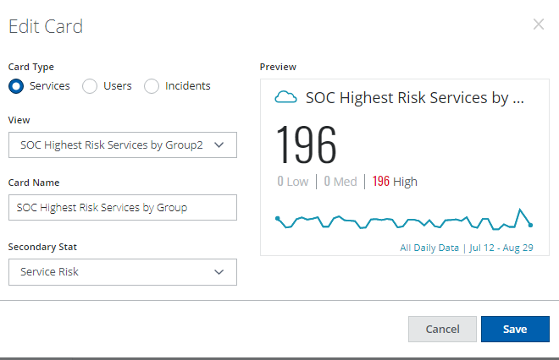

SOC Most Vulnerable Services
SOC High Risk Services By Department
SOC Highest Risk Services by Group
SOC High Risk Service which allows anonymous use
Uploads greater than 5 gig and 10gig

Service Groups Remove All
Trusted - Marketing Services
Trusted - Collaboration Srvcs
Trusted - Finance Services
Trusted - Development Services
Trusted - HR Services
Trusted - Business Intelligence
Trusted - IT Services
Trusted - Education Services
Trusted - Project Manager Srvc
Trusted - Security Services
Trusted - Social Media Service
Trusted - Healthcare Services
Trusted Cloud Infrastructure
Trusted - Srvc Desk - Support
Trusted - Logistics Services
Trusted - eCommerce Services
Trusted Content Sharing Srvcs
Trusted - Network Services
Trusted - CRM Services
Trusted - Legal Services
Trusted - Tracking Services
Trusted - Cloud Storage Srvcs
Trusted Backup - Archive Srvcs
Trusted Media Services
Trusted Procurement Services
Trusted - Web API Services
Trusted - ERP Services
Trusted Sanctioned Services
High Risk Blocks
Service Already Blocked by MWG
SOC Highest Risk Services - by Group
SOC - Highest Risk Services By Category
SOC - Highest Risk Services by Service Category
SOC - Highest Risk Services by Department

