SCCM Patching Tutorial

- Creating Collect
  - Right Click sub-collection or collection an select new collection

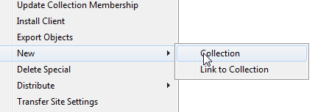
1.2 Collection Wizard will start. Name your collection and click next

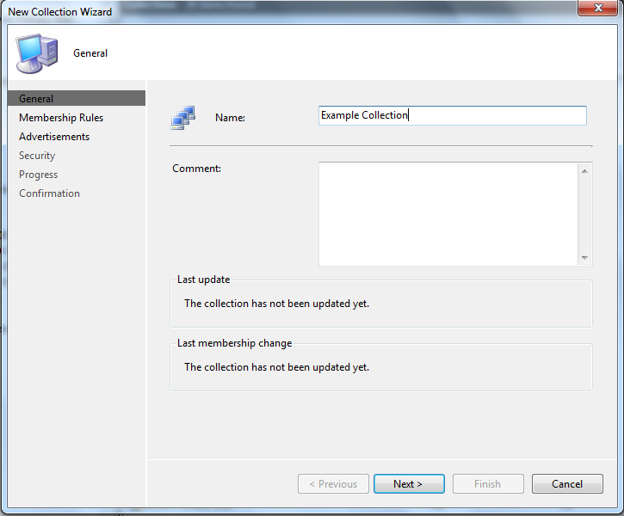

1.3 Select selection criteria or click next if you are going to create from list. If you do not select a selection criteria a pop will come up warning that no criteria select ignore and continue.
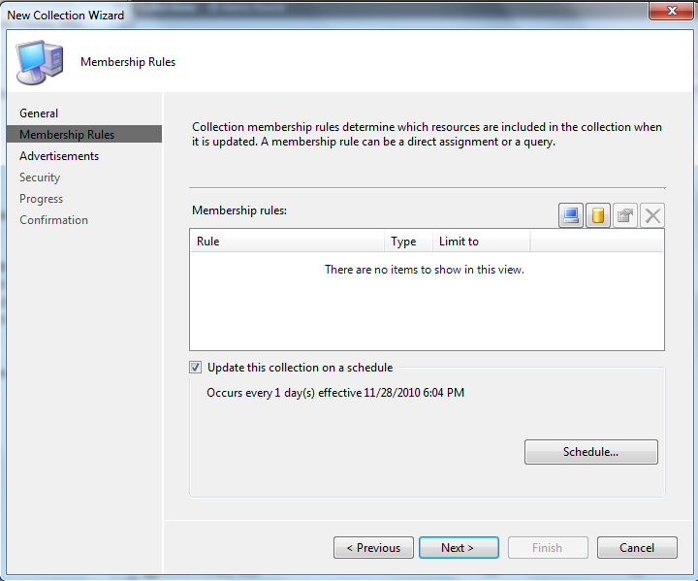

1.4 Select next until a close button is selected and click close
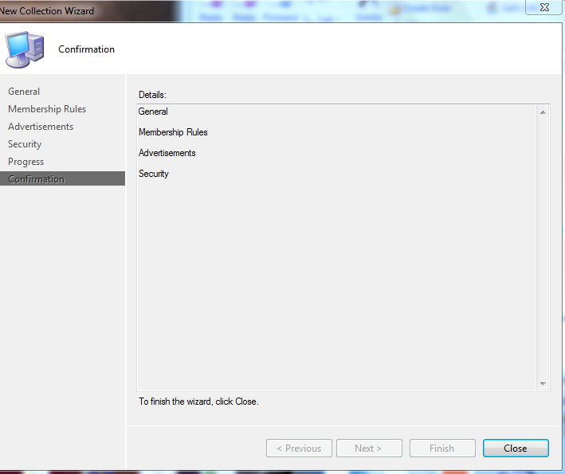

1.5 To add workstations or servers from list (Right Click Tools Required) right click collection and select ConfigMgr Collection Tools >> Add Systems to Collection (This menu comes from Right Click Tools)

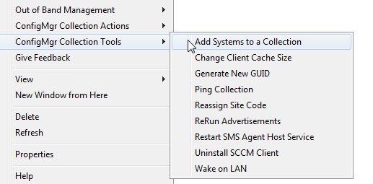
1.6 Input computer names or cut and paste from list and click “Add PCs To Collection”. After systems have been added to collection click exit button.
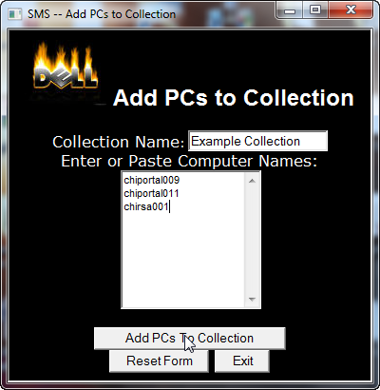

1.7. To see systems in collection right click your collection and select “Update Collection Membership
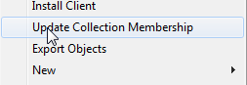

- Add Maintenance Window to Collection
2.1 Right click your collection and on menu select “Modify Collection Settings”
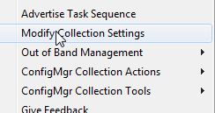
2.2 On Maintenance Window Tab select  icon to create new maintenance window.
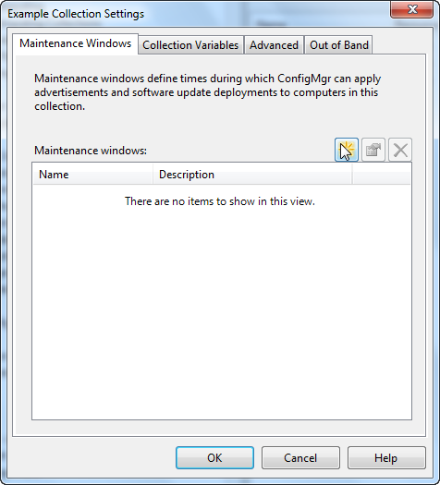
2.3 Name your schedule and create the time and day of your maintenance window. Click ok. For more on options go to http://technet.microsoft.com/en-us/library/bb693981.aspx

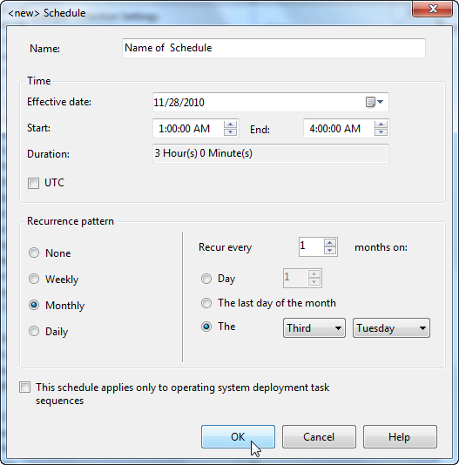

- Creating update list
3.1 In SCCM Console go to Computer Management >> Software Updates >> Update Repository >> Search Folders >> Enterprise Searches >> Year of Patches. Then select patches that need to be deployed. Right click and select update list.
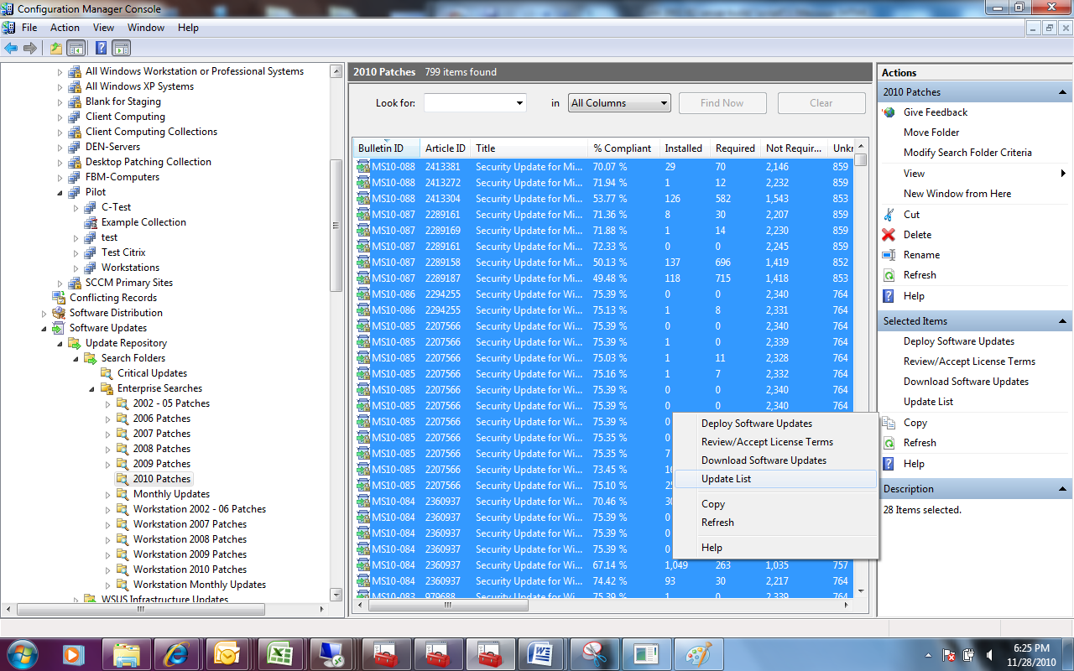
3.2 In Update List Wizard select “Create a new update list” and select “Download the files associated with the selected software updates”. Name update list and select next.
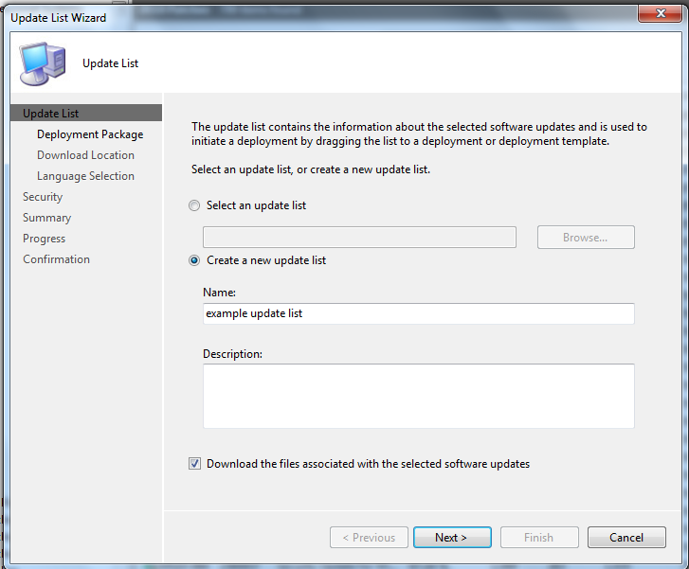
3.3 Select “Create a new deployment package”. Name your deployment package. Input Package Source UNC path.
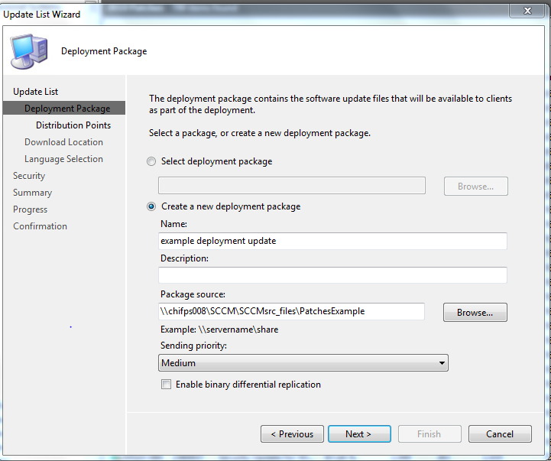
3.4 Select browse on distribution point wizard.
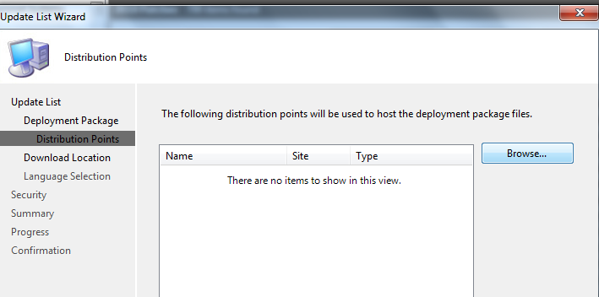
3.5 Select distribution points for patches and click ok.
Check-mark the distribution server or servers

3.6 Verify that distribution points click next.
Verify the Servers selected are in the “Name, Site and Type” columns.

3.7 Download software updates from internet click next until progress menu.
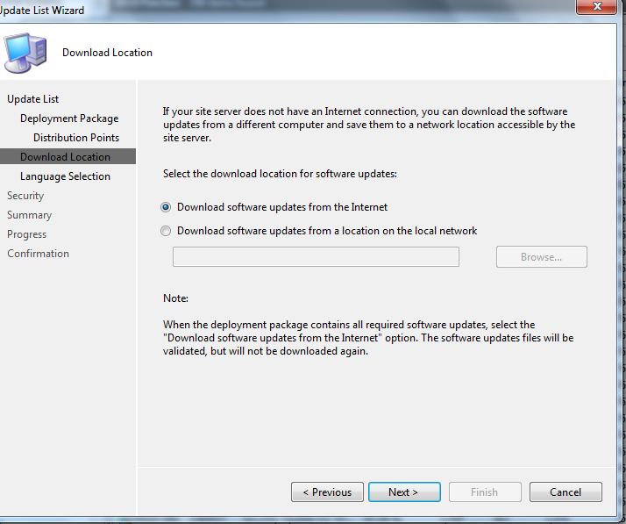
3.8 During progress menu the software updates are downloaded. If a lot of software updates are being downloaded it may take a while.
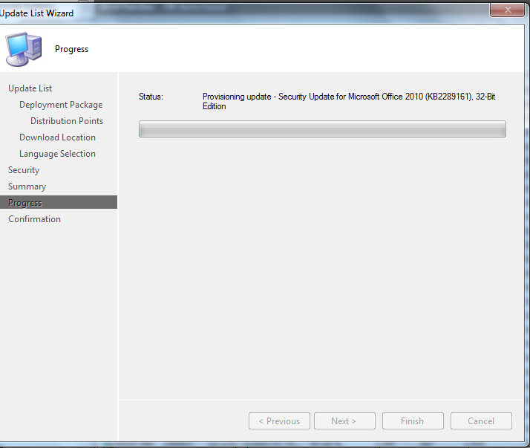

3.9 After software updates are download click close.
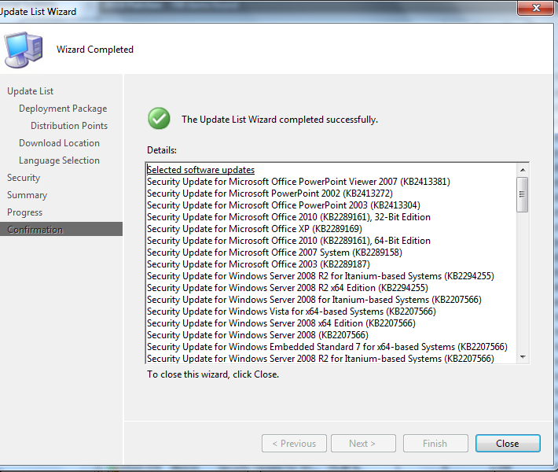

- After software update list is created the next step is to create a deployment management package.
4.1 Go to Software Updates >> Update Lists >> select update list. Right click update list and select “Deploy Software Updates” on the drop down menu.

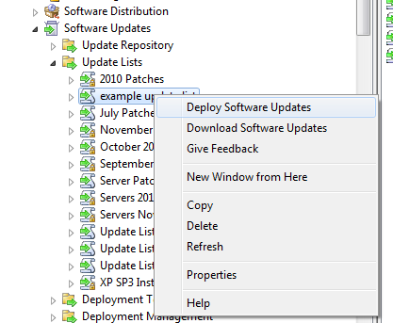

4.2 Deploy Software Updates Wizard will start. Name package and select next.
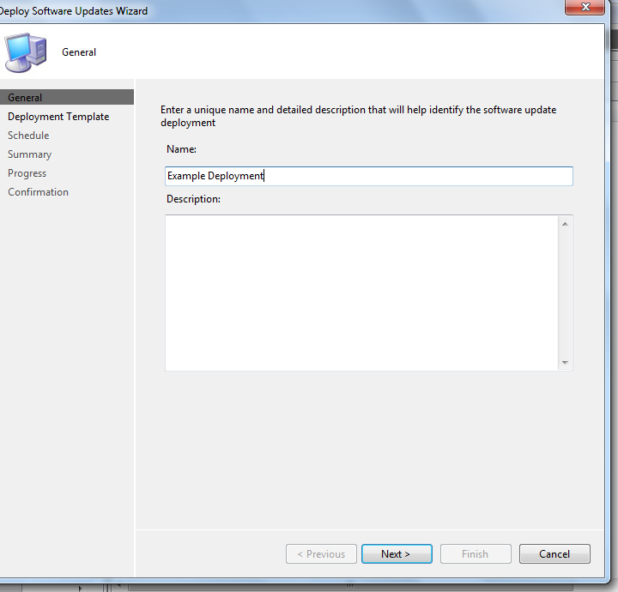
4.3 Select deployment template.
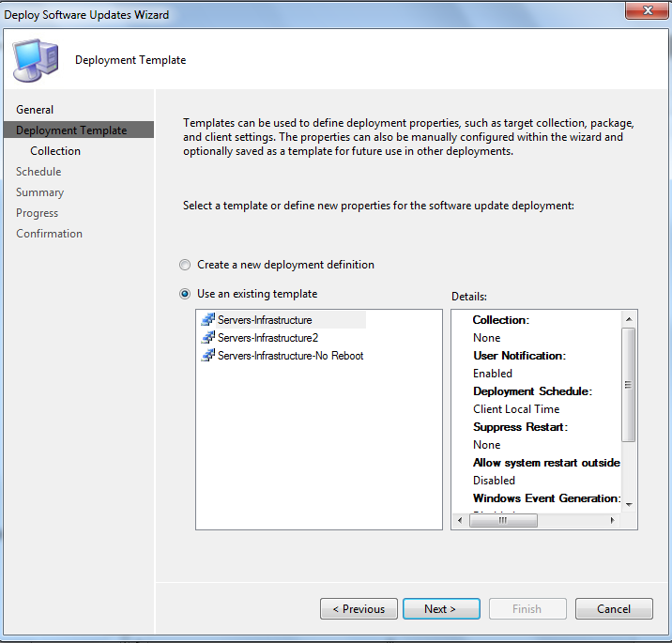
4.4 In collection page select browse and blank for staging
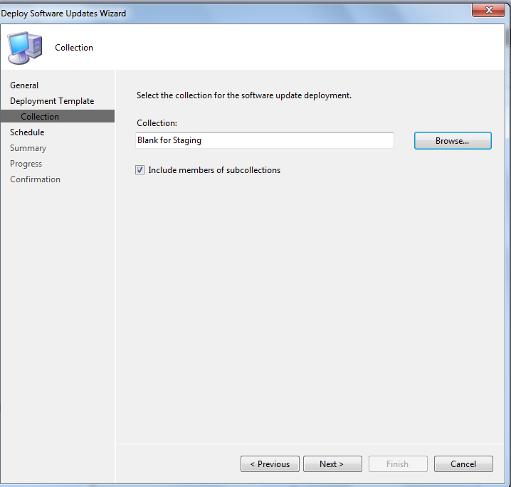

4.5 On Deployment Schedule select “As soon as possible”. (Important: It is important that maintenance windows are set on your collections. If no maintenance window is set then patches will install immediately when applied to collection.)
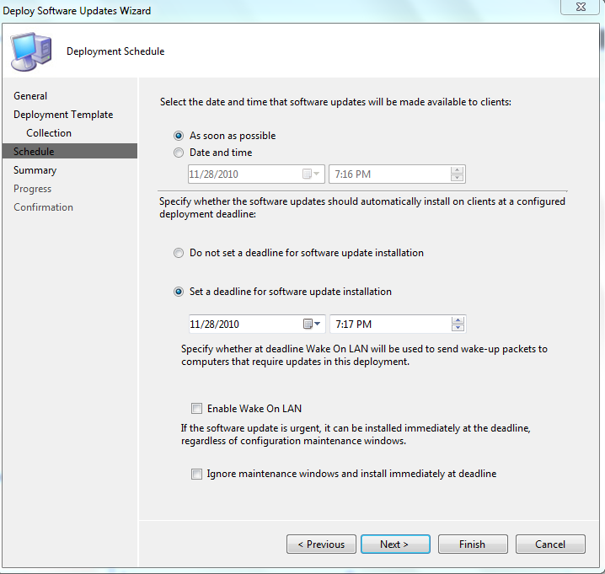
4.6 Click next until finished and then close.
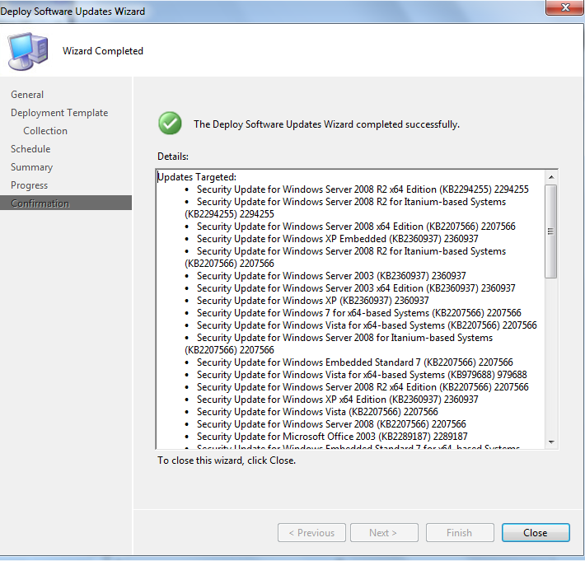
5. Appling Deployment Management to collection. It is important to apply deployment management package to a top level collection if possible. Each deployment package will take up disk space on distribution point. (Important: It is important that maintenance windows are set on your collections. If no maintenance window is set then patches will install immediately when applied to collection.)
5.1 Go to Software Updates > Deployment Management >> Select your deployment package. Right click your deployment package and select properties.

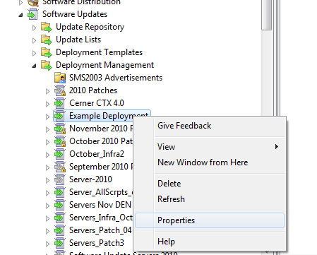
5.2 Go to collection tab and browse to your collection. It is important to apply deployment management package to a top level collection if possible. Each deployment package will take up disk space on distribution point.
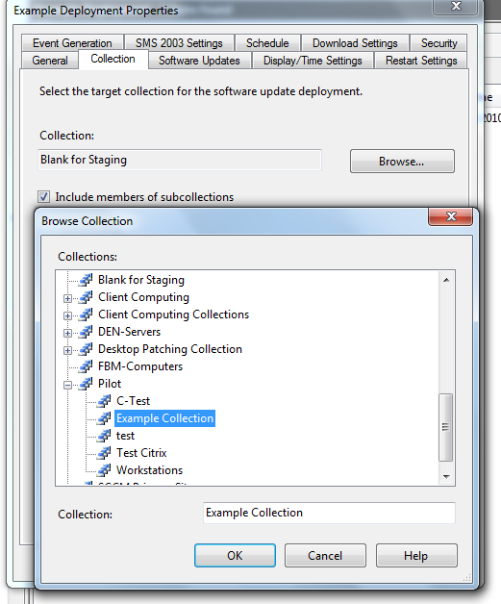

6. Key Reports for Software Updates
6.1 Software Updates - A. Compliance >> Compliance 3 - Update list (per update)
Report Comment
- This report returns the compliance data for software updates defined in an Update List.
- Use this report to see if your servers in a collection needs patches

6.2 Software Updates - C. Deployment States >> Enforcement states for a deployment –
Report Comment
- This report returns the enforcement states for a specific software update deployment, which is typically the second phase of a deployment assessment. For the overall progress of software update installation, use this report in conjunction with 'Evaluation state for a specific software update deployment'.
- This report will show what state Servers or Workstation in a deployment( ie compliant, downloading, failed, unknown, installing or waiting for maintenance windows)
6.3 Link Explaining Software Update Reports
http://technet.microsoft.com/en-us/library/bb632839.aspx
Key Links for more Information for software Updates
TechNet Library for software Updates
http://technet.microsoft.com/en-us/library/bb680701.aspx

Log files for Troubleshooting software updates.
http://technet.microsoft.com/en-us/library/bb693878.aspx
Link for Troubleshooting software updates
http://technet.microsoft.com/en-us/library/bb693492.aspx
Links to Software Updates Webcasts and Virtual Labs
http://www.microsoft.com/events/series/technetmms.aspx?tab=Webcasts&seriesid=37&webcastid=4166
https://www.microsoft.com/resources/virtuallabs/step1-technet.aspx?LabId=e2d55c9f-9ad0-4afe-96c7-844fe815d7b3&BToken=reg
TechNet Blog Software updates
http://blogs.technet.com/b/configurationmgr/archive/2009/08/17/guide-to-software-updates-deployment-in-configuration-manager-2007.aspx
http://blogs.technet.com/b/configurationmgr/archive/2009/08/20/guide-to-software-updates-deployment-in-configuration-manager-2007-part-2.aspx
Public Document on how patching process may be done.
http://collab.catholichealth.net/gm/document-1.9.746867/SCCM%20Patch%20Management_1.3_Public.doc
Windows-NOOBS SCCM Software update guide
Configuring Software Update point within SCCM
Configuring Software Update Point within SCCM
Configuring another server to run WSUS for SCCM
Setting up a Software Update Point on a Remote Server
Managing monthly updates in SCCM
On the Second Tuesday of every Month
Deploying Service Packs using SCCM
How can I deploy service packs using the software update point
Using Update Lists when deploying Monthly Updates
Part 1. Creating the Update List and Deployment Management Task
Using Update Lists when deploying Monthly Updates
Part 2. Target the Deployment Management Task and Verify
Using Update Lists when deploying Monthly Updates
Part 3. Using reports to report on Compliance
Updates are not being installed automatically - Windows Update Icon
The Windows Update icon appears even though SCCM is managing updates

